**REPORT ON MY DOCTOR APPOINTMENT DASHBOARD (LARAVEL )**

DNYANESHWARI GOGAWALE

dell

[Company name]  [Company address]

**INTRODUCTION :**

**WHY WEB DEVELOPMENT ?**

Web development various tasks from coding,to designing to working and functioning of a website/webpage .It involves creating,sustaining and maintaining of webpages and websites across the internet .

web developer is the one coding the designs given to them into a website .

**WHY LARAVEL-FRAMEWORK ?**

Laravel is a PHP framework for building web applications with a clean, elegant syntax. It offers tools and libraries for tasks like:

* **Routing**: Define web routes and APIs easily.
* **Eloquent ORM**: Manage database relationships with an intuitive syntax.
* **Blade Templating**: Create dynamic views with Blade, Laravel's lightweight templating engine.
* **Authentication & Authorization**: Built-in user login, registration, and role management.
* **Artisan CLI**: Run commands for migrations, seeding, testing, and more.
* **Middleware**: Add layers to HTTP requests for security and logging.

Laravel speeds up development with clean code principles, a modular structure, and robust, scalable design.

**why a DOCTOR APPOINTMENT DASHBOARD ?**

A doctor appointment dashboard simplifies scheduling, enhances patient experience, and reduces no-shows with easy booking, reminders, and secure communication. It’s a modern, efficient way to connect patients and healthcare providers, saving time and improving access to care.

**category of DOCTORS :**

1. **HEART SPECIALISTS**
2. **DENTISTS**
3. **VETS**
4. **ORTHOPAEDISTS**

**used:**  HTML ,CSS, BOOTSTRAP , JAVA-SCRIPT.LARAVEL FRAMEWORK

**NAME OF FILES USED :**

1. Visible1.blade.php
2. Signup.php**(only for doctor dashboard)**
3. Login.php**(only for doctor dashboard)**
4. style.css
5. CONTROLLER FOLDER (2 controllers)
6. 2 MODELS
7. Web.php
8. Multiple header ,footer files
9. Script.js
10. BOOK.blade.php
11. MIGRATION folder

**ABSTRACT :**

used Bootstrap basic layouts for creating CAROUSEL and Navigation Bar at the top with HOSPITALS AND DOCTORS in the background carousel .

Navigation bar : DOCTOR INTERFACE and Contact US are anchor tags and open their respective ROUTES(doctor/registration) and (contact.html) .One corresponding to form filling about FEEDBACK and QUERY resolver ; while the other showing the quirks(specifications or features) of website-family .

Log-in and Sign-up both triggering Modals to display forms needed to be filled in .The data of Sign-up form is later saved on LARAVEL TABLES

The icon in the far right on navigation bar of a COAT is the logo of the website and is used to return to homepage .

when BOOK NOW option is clicked for a particular DOC,webpage redirected to ROUTE \BOOK which contains a form to be filled forTIMINGS,NAME,EMAIL ADDRESS. ;This Data is saved In /phpmyadmin .

divided the width of the screen into 5 parts to fit 5 bootstrap CARDS .

the alerts and popups and modals all used are helpful In reflecting our actions

**UNDERSTANDING APPOINT-MENT :**

Two interfaces : USER , DOCTORS

* **User :** user interface allows to explore various doctors .
* Booking appointments .
* Feeding this data to our laravel database tables .
* **DOCTOR :** LOG IN ,SIGN-UP and check in their respective appointments .
* Retrieving the data fed by the user via forms .

**CONCLUSION :**

This website helps smoothen and easen consumer-dealer relations .Reduces the physical TIME and the commercializing gap between PATIENTS ,DOCTORS .

It is easy to use and user interface friendly along with being responsive .

Being virtually attractive and kids friendly .Trusted and reliable source of code .

As is visually appealing therefore even aides for people who cannot read .

**SOURCE CODE :**

ATTATCHING A ZIP FILE OF ENTIRE CODE WITH THIS REPORT .please refer that;Below are important ones.

**FUTURE ENHANCEMENTS :**

* INTEGRATING PAYMENT METHOD UPI
* VIDEO COUNSELLING THHROUGH DASHBOARD ITSELF .
* LOGIN AND SIGNUP OPTIONS AVAILABLE FOR USERS AS WELL TO TRACK THEIR ENDEAVOURS
* MORE POINTS IMPLYING FREE HEALTHCARE CHECKUPS REGULARLY .
* Making the doctor family big ,therefore better resources and better healthcare .

**FILE 1 : visible.blade.php**

<!DOCTYPE html>

<html lang="en">

<head>

<!-- Required meta tags -->

<meta charset="utf-8" />

<meta name="viewport" content="width=device-width, initial-scale=1" />

<!-- Bootstrap CSS -->

<link

href="https://cdn.jsdelivr.net/npm/bootstrap@5.0.2/dist/css/bootstrap.min.css"

rel="stylesheet"

integrity="sha384-EVSTQN3/azprG1Anm3QDgpJLIm9Nao0Yz1ztcQTwFspd3yD65VohhpuuCOmLASjC"

crossorigin="anonymous"

/>

<!--personal css-->

<link rel="stylesheet" href="/index.css" />

<title>DOCTOR APPOINTMENT DASHBOARD </title>

<<style>

.btn.btn-primary {

background-color: rgb(225, 35, 235);}

</style>

</head>

<body>

<nav class="navbar navbar-expand-lg bg-body-tertiary navbar-dark bg-dark " >

<div class="container-fluid">

<a class="navbar-brand" href="/" ><img src="https://i.etsystatic.com/20573433/r/il/e61cf8/3088631339/il_1080xN.3088631339_1j2t.jpg" height="50" alt="homepage"></a>

<button class="navbar-toggler" type="button" data-bs-toggle="collapse" data-bs-target="#navbarSupportedContent" aria-controls="navbarSupportedContent" aria-expanded="false" aria-label="Toggle navigation">

<span class="navbar-toggler-icon"></span>

</button>

<div class="collapse navbar-collapse" id="navbarSupportedContent">

<ul class="navbar-nav me-auto mb-2 mb-lg-0">

<li class="nav-item">

<a class="btn btn-primary" href="doctor/registration" role="button">DOCTOR INTERFACE </a>

</li>

<li class="nav-item">

<a class="nav-link" href="./contact.html">Contact us </a>

</li>

<li class="nav-item dropdown">

<a class="nav-link dropdown-toggle" href="#" role="button" data-bs-toggle="dropdown" aria-expanded="false">

Dropdown

</a>

<ul class="dropdown-menu">

<li><a class="dropdown-item" href="#">Action</a></li>

<li><a class="dropdown-item" href="#">Another action</a></li>

<li><hr class="dropdown-divider"></li>

<li><a class="dropdown-item" href="#">Something else here</a></li>

</ul>

</li>

<li class="nav-item">

<a class="nav-link disabled" aria-disabled="true">Disabled</a>

</li>

</ul>

<form class="d-flex" role="search">

<input class="form-control me-2" type="search" placeholder="Search" aria-label="Search">

<button class="btn btn-outline-success" type="submit">Search</button>

</form>

<!-- LOGIN -->

<button type="button" class="btn btn-danger" data-bs-toggle="modal" data-bs-target="#staticBackdropA">

Login

</button>

<!-- Modal -->

<div class="modal fade" id="staticBackdropA" data-bs-backdrop="static" data-bs-keyboard="false" tabindex="-1" aria-labelledby="staticBackdropALabel" aria-hidden="true">

<div class="modal-dialog">

<div class="modal-content">

<div class="modal-header">

<h1 class="modal-title fs-5" id="staticBackdropALabel">LOGIN FORM </h1>

<button type="button" class="btn-close" data-bs-dismiss="modal" aria-label="Close"></button>

</div>

<div class="modal-body">

<form onsubmit ="return validation()">

<div class="form-group" >

<label for="exampleInputEmail1">Email address</label>

<input type="email" class="form-control" placeholder="enter valid email-id" id="exampleInputEmail1" aria-describedby="emailHelp" >

<small id="emailHelp" class="form-text text-muted">We'll never share your email with anyone else.</small>

</div>

<div class="form-group">

<label for="exampleInputPassword1">Password</label>

<input type="password" class="form-control" id="exampleInputPassword1">

</div>

<div class="form-group form-check">

<input type="checkbox" class="form-check-input" id="exampleCheck1">

<label class="form-check-label" for="exampleCheck1">Check me out</label>

</div>

</form>

</div>

<div class="modal-footer">

<button type="button" class="btn btn-secondary" data-bs-dismiss="modal">Close</button>

<button type="submit" class="btn btn-primary btn-lg disabled">Login</button>

</div>

</div>

</div>

</div>

<!--SIGN UP modal -->

<button type="button" class="btn btn-danger" data-bs-toggle="modal" data-bs-target="#staticBackdropB">

Sign up

</button>

<!-- Modal -->

<div class="modal fade" id="staticBackdropB" data-bs-backdrop="static" data-bs-keyboard="false" tabindex="-1" aria-labelledby="staticBackdropBLabel" aria-hidden="true">

<div class="modal-dialog">

<div class="modal-content">

<div class="modal-header">

<h1 class="modal-title fs-5" id="staticBackdropBLabel">SIGN-UP FORM </h1>

<button type="button" class="btn-close" data-bs-dismiss="modal" aria-label="Close"></button>

</div>

<div class="modal-body">

<form onsubmit ="return validation()" name="signupform" id="form-sheet01" >

<div class="form-group">

<div class="mb-3">

<label for="exampleInput1" class="form-label">Name</label>

<input name="NAME" type="text" class="form-control" id="exampleInput1">

<span id="error-name" style="color: red; font-size: 10px;"></span>

</div>

<div class="mb-3">

<label for="exampleInput2" class="form-label">Contact Number</label>

<input name="NUMBER" type="number" class="form-control" id="exampleInput2">

<span id="error-number" style="color: red; font-size: 10px;"></span>

</div>

<label for="exampleInputEmail1">Email address</label>

<input name="EMAIL_ID"type="email" class="form-control" id="exampleInputEmail1" aria-describedby="emailHelp">

<small id="emailHelp" class="form-text text-muted">We'll never share your email with anyone else.</small>

<span id="error-number" style="color: red; font-size: 10px;"></span>

</div>

<div class="form-group">

<label for="exampleInputPassword1">Password</label>

<input type="password" class="form-control" id="exampleInputPassword1">

<span id="error-password" style="color: red; font-size: 10px;"></span>

</div>

<div class="form-group">

<label for="exampleInputPassword2">Confirm Password</label>

<input type="password" class="form-control" id="exampleInputPassword2">

<span id="error-vpassword" style="color: red; font-size: 10px;"></span>

<br><br><hr>

<div class="modal-footer">

<button type="button" class="btn btn-secondary " data-bs-dismiss="modal">Close</button>

<button type="submit" class="btn btn-primary btn-lg disabled" id="submit01">SUBMIT </button>

</div>

</div>

</form>

</div>

</div>

</div>

</div>

</div>

</nav>

<!--carousel-->

<div id="carouselExampleCaptions " class="carousel slide carousel-fade" >

<div class="carousel-indicators">

<button type="button" data-bs-target="#carouselExampleCaptions" data-bs-slide-to="0" class="active" aria-current="true" aria-label="Slide 1"></button>

<button type="button" data-bs-target="#carouselExampleCaptions" data-bs-slide-to="1" aria-label="Slide 2"></button>

<button type="button" data-bs-target="#carouselExampleCaptions" data-bs-slide-to="2" aria-label="Slide 3"></button>

</div>

<div class="carousel-inner height="100">

<div class="carousel-item active ">

<img src="https://img.freepik.com/premium-vector/doctor-office-interior-medical-cabinet-consultation-room-hospital-clinic_313242-1080.jpg?w=360" class="d-block w-100" alt="..." height="400">

<div class="carousel-caption d-none d-md-block bg-transparent text-dark" >

<h1><b><ul>Welcome to APPOINT-MINT </ul></b></h1>

<p><b>APPOINT-MINT : check-it-out!! </b> </p>

<button class="btn btn-primary">Heart</button>

<button class="btn btn-success">ENT</button>

<button class="btn btn-danger">DENTISTS</button>

</div>

</div>

<div class="carousel-item">

<img src="https://img.freepik.com/premium-vector/male-female-doctors-white-medical-coats-standing-with-arms-folded-group-medics-illustration-flat-style_213307-24.jpg" class="d-block w-100" alt="..." height="400">

<div class="carousel-caption d-none d-md-block text-dark ">

<b> <h1>Welcome to APPOINT-MINT </h1>

<p>APPOINT-MINT : check-it-out!! </p></b>

<button class="btn btn-primary">PUNE</button>

<button class="btn btn-success">MUMBAI</button>

<button class="btn btn-danger">BENGALURU</button>

</div>

</div>

<div class="carousel-item">

<img src="https://static.vecteezy.com/system/resources/previews/000/656/917/original/vector-set-of-doctor-cartoon-characters-medical-staff-team-concept-in-front-of-hospital.jpg" class="d-block w-100" alt="..." height="400">

<div class="carousel-caption d-none d-md-block text-dark">

<b><h1>Welcome to APPOINT-MINT </h1>

<p>APPOINT-MINT : check-it-out!! </p> </b>

<button class="btn btn-primary">KOLKATA</button>

<button class="btn btn-success">HYDERABAD</button>

<button class="btn btn-danger">NEW-DELHI</button>

</div>

</div>

</div>

<button class="carousel-control-prev" type="button" data-bs-target="#carouselExampleCaptions" data-bs-slide="prev">

<span class="carousel-control-prev-icon" aria-hidden="true"></span>

<span class="visually-hidden">Previous</span>

</button>

<button class="carousel-control-next" type="button" data-bs-target="#carouselExampleCaptions" data-bs-slide="next">

<span class="carousel-control-next-icon" aria-hidden="true"></span>

<span class="visually-hidden">Next</span>

</button>

</div>

<!--alert-->

<div class="alert alert-warning alert-dismissible fade show " role="alert">

<h4 class="alert-heading">NAMASTE !! </h4>

<b>NOTE</b>:<strong><p>ONLY DOCTORS ARE ALLOWED TO REGISTER,LOGIN.TO ENABLE THESE FEATURES USE DOCTOR INTERFACE.(/doctor/registration or /doctor/login ROUTES )<br><hr>

<b><h3>APPOINT-MINT<br></h3></b>"Freshen up your healthcare experience with AppointMINT – where your medical appointments are always in mint condition! This refreshing dashboard makes scheduling a breeze, ensuring you never miss a check-up or follow-up. With a sprightly interface, AppointMINT offers easy appointment booking, sweet reminders, and seamless communication with your healthcare heroes. Whether you're feeling under the weather or just need a routine check-in, AppointMINT is here to help you stay healthy and happy. Get ready to savor a crisp, clear path to wellness – because with AppointMINT, good health is just a click away!" </p> </strong>

<hr>

<button type="button" class="btn-close" data-bs-dismiss="alert" aria-label="Close"></button>

</div>

<!-- Optional JavaScript; choose one of the two! -->

<!-- Option 1: Bootstrap Bundle with Popper -->

<script

src="https://cdn.jsdelivr.net/npm/bootstrap@5.0.2/dist/js/bootstrap.bundle.min.js"

integrity="sha384-MrcW6ZMFYlzcLA8Nl+NtUVF0sA7MsXsP1UyJoMp4YLEuNSfAP+JcXn/tWtIaxVXM"

crossorigin="anonymous"

></script>

<!-- Option 2: Separate Popper and Bootstrap JS -->

<!--

<script src="https://cdn.jsdelivr.net/npm/@popperjs/core@2.9.2/dist/umd/popper.min.js" integrity="sha384-IQsoLXl5PILFhosVNubq5LC7Qb9DXgDA9i+tQ8Zj3iwWAwPtgFTxbJ8NT4GN1R8p" crossorigin="anonymous"></script>

<script src="https://cdn.jsdelivr.net/npm/bootstrap@5.0.2/dist/js/bootstrap.min.js" integrity="sha384-cVKIPhGWiC2Al4u+LWgxfKTRIcfu0JTxR+EQDz/bgldoEyl4H0zUF0QKbrJ0EcQF" crossorigin="anonymous"></script>

-->

<!--items existential crisis -->

<br>

<div><b><h2>HEART SPECIALISTS : <span class="badge text-bg-warning">New</span> </h2> </b><hr>

<div class="row row-cols-1 row-cols-md-5 g-5">

<div class="col">

<div class="card h-100 shadow">

<img src="https://cdn3.iconfinder.com/data/icons/medical-hospital-14/3023/Avatar-Man-Doctor-Hospital-Medical-Clinic-Profile-Treatment-512.png" class="card-img-top" alt="..." >

<div class="card-body">

<h5 class="card-title"><b>DHANANJAY RAJPOOT </b></h5>

<p class="card-text">consultant fees: <button type="button" class="btn btn-warning">$200 for initial consult, $150 for follow-ups </button>

<br><hr><B>Timings Available:</B> Mon, Wed, Fri (10 AM - 3 PM)<br><hr>

<b>Education:</b> MBBS, MD (Cardiology), Harvard University<br><hr>

<b>Years of Experience:</b> 15 years</p> <hr>

<!-- Button trigger modal -->

<button type="button" class="btn btn-primary " data-bs-toggle="modal" data-bs-target="#staticBackdrop">

More details

</button>

<!-- Modal -->

<div class="modal fade" id="staticBackdrop" data-bs-backdrop="static" data-bs-keyboard="false" tabindex="-1" aria-labelledby="staticBackdropLabel" aria-hidden="true">

<div class="modal-dialog modal-dialog-scrollable">

<div class="modal-content">

<div class="modal-header">

<h1 class="modal-title fs-5" id="staticBackdropLabel">Modal title</h1>

<button type="button" class="btn-close" data-bs-dismiss="modal" aria-label="Close"></button>

</div>

<div class="modal-body">

<b>Timings Available:</b> Mon, Wed, Fri (10 AM - 3 PM)<hr><br>

<b>Education:</b> MBBS, MD (Cardiology), Harvard University

<b>Years of Experience:</b> 15 years

<b>Languages Spoken:</b> English, Spanish

<b><hr><br>Consultation Fees:</b> $200 for initial consult, $150 for follow-ups

<b><hr><br>Special Procedures:</b> Electrocardiogram (ECG), Stress Testing, Cardiac Catheterization

<b><hr><br>Professional Associations:</b> American College of Cardiology (ACC)

<b><hr><br>Patient Reviews and Ratings:</b> ⭐⭐⭐⭐ (4.7/5 based on 120 reviews)

<b><hr><br>Telemedicine Availability:</b> Yes

<b><hr><br>Insurance Accepted: </b>Medicare, Blue Cross Blue Shield, Cigna

<b><hr><br>Awards and Recognition:</b> Awarded “Best Cardiologist” in 2018

<b><hr><br>Publications: </b>25+ papers on heart disease prevention

<b><hr><br>Additional Clinic Staff:</b> 2 Nurse Practitioners, 1 Medical Assistant

<b><hr><br>Success Rate:</b> 98% for cardiac procedures

<b><hr><br>Cancellation Policy:</b> 24-hour notice required, $50 fee for late cancellations

<b><hr><br>Average Waiting Time:</b> 15-20 minutes

<b><hr><br>Location: </b>Harvard Medical Clinic, Boston, MA (Map Link)

<b><hr><br>Contact:</b> (555) 123-4567, linda.brown@harvardmed.com

</div>

<div class="modal-footer">

<button type="button" class="btn btn-secondary" data-bs-dismiss="modal">Close</button>

<a class="btn btn-primary" href="BOOK" role="button">Book now</a>

</div>

</div>

</div>

</div>

</div>

<div class="card-footer">

<small class="text-body-secondary">Modern Classic </small>

</div>

</div>

</div>

<div class="col">

<div class="card h-100 shadow ">

<img src="https://png.pngtree.com/png-clipart/20210928/ourmid/pngtree-cute-cartoon-sticker-of-a-male-doctor-wearing-medical-health-mask-png-image_3960842.png" class="card-img-top" alt="...">

<div class="card-body">

<h5 class="card-title">NIKHIL NAIR </h5>

<p class="card-text">consultant fees: <button type="button" class="btn btn-warning"> $190 for initial consult, $140 for follow-ups </button> <hr>

<b>Timings Available:</b> Tue, Thu, Sat (11 AM - 4 PM)<br><hr>

<b>Education:</b> MBBS, MD (Cardiology), Oxford University<br><hr>

<b>Years of Experience:</b> 12 years<br></p> <hr>

<!-- Button trigger modal -->

<button type="button" class="btn btn-primary" data-bs-toggle="modal" data-bs-target="#staticBackdrop2">

More details

</button>

<!-- Modal -->

<div class="modal fade" id="staticBackdrop2" data-bs-backdrop="static" data-bs-keyboard="false" tabindex="-1" aria-labelledby="staticBackdrop2Label" aria-hidden="true">

<div class="modal-dialog modal-dialog-scrollable">

<div class="modal-content">

<div class="modal-header">

<h1 class="modal-title fs-5" id="staticBackdrop2Label">Modal title</h1>

<button type="button" class="btn-close" data-bs-dismiss="modal" aria-label="Close"></button>

</div>

<div class="modal-body">

<b>Dr. Nikhil Nair </b><br>

<b>Specialization:</b> Heart Specialist<br>

<b>Timings Available:</b> Tue, Thu, Sat (11 AM - 4 PM)<br>

<b>Education:</b> MBBS, MD (Cardiology), Oxford University<br>

<b>Years of Experience:</b> 12 years<br>

<b>Languages Spoken:</b> English, Arabic<br>

<b>Consultation Fees:</b> $190 for initial consult, $140 for follow-ups<br>

<b>Special Procedures:</b> Angioplasty, Stent Placement, Echocardiography<br>

<b>Professional Associations:</b> British Cardiac Society<br>

<b>Patient Reviews and Ratings:</b> ⭐⭐⭐⭐ (4.5/5 based on 100 reviews)<br>

<b>Telemedicine Availability:</b> No<br>

<b>Insurance Accepted:</b> Aetna, Cigna, UnitedHealthcare<br>

<b>Awards and Recognition:</b> Pioneer in non-invasive cardiology<br>

<b>Publications:</b> Papers on new heart valve technologies<br>

<b>Additional Clinic Staff:</b> 1 Medical Assistant<br>

<b>Success Rate:</b> 94% for angioplasty procedures<br>

<b>Cancellation Policy:</b> 24-hour notice required, $50 fee<br>

<b>Average Waiting Time:</b> 10-15 minutes<br>

<b>Location:</b> Oxford Heart Center, Oxford, UK (<a href="#">Map Link</a>)<br>

<b>Contact:</b> +44-207-1234567, ahmed.khan@oxfordcardio.org<br>

<hr>

</div>

<div class="modal-footer">

<button type="button" class="btn btn-secondary" data-bs-dismiss="modal">Close</button>

<a class="btn btn-primary" href="BOOK" role="button">Book now</a>

</div>

</div>

</div>

</div>

</div>

<div class="card-footer">

<small class="text-body-secondary">Tortured Poets Department </small>

</div>

</div>

</div>

<div class="col">

<div class="card h-100 shadow ">

<img src="https://img.freepik.com/premium-photo/illustration-portrays-confidence-female-professional-white-coat-stethoscope-draped-around-th_1015897-207.jpg" class="card-img-top" alt="...">

<div class="card-body">

<h5 class="card-title">NUSARAT KHAN </h5>

<p class="card-text">consultant fees: <button type="button" class="btn btn-warning"> $180 for initial consult, $130 for follow-ups </button><hr>

<b>Timings Available:</b> Mon - Fri (9 AM - 2 PM)<br><hr>

<b>Education:</b> MBBS, DM (Cardiology), AIIMS, India<br><hr>

<b>Years of Experience:</b> 9 years<br></p> <hr>

<!-- Button trigger modal -->

<button type="button" class="btn btn-primary" data-bs-toggle="modal" data-bs-target="#staticBackdrop3">

More details

</button>

<!-- Modal -->

<div class="modal fade" id="staticBackdrop3" data-bs-backdrop="static" data-bs-keyboard="false" tabindex="-1" aria-labelledby="staticBackdrop3Label" aria-hidden="true">

<div class="modal-dialog modal-dialog-scrollable">

<div class="modal-content">

<div class="modal-header">

<h1 class="modal-title fs-5" id="staticBackdrop3Label">Modal title</h1>

<button type="button" class="btn-close" data-bs-dismiss="modal" aria-label="Close"></button>

</div>

<div class="modal-body">

<b>Dr. Nusarat Khan </b><br>

<b>Specialization:</b> Heart Specialist<br>

<b>Timings Available:</b> Mon - Fri (9 AM - 2 PM)<br>

<b>Education:</b> MBBS, DM (Cardiology), AIIMS, India<br>

<b>Years of Experience:</b> 9 years<br>

<b>Languages Spoken:</b> English, Hindi<br>

<b>Consultation Fees:</b> $180 for initial consult, $130 for follow-ups<br>

<b>Special Procedures:</b> Coronary Artery Bypass, Cardiac Imaging<br>

<b>Professional Associations:</b> Indian Heart Association<br>

<b>Patient Reviews and Ratings:</b> ⭐⭐⭐⭐ (4.8/5 based on 140 reviews)<br>

<b>Telemedicine Availability:</b> Yes<br>

<b>Insurance Accepted:</b> Cigna, UnitedHealthcare, ICICI Lombard<br>

<b>Awards and Recognition:</b> Recognized for cardiac imaging advancements<br>

<b>Publications:</b> Multiple articles on cardiac imaging<br>

<b>Additional Clinic Staff:</b> 2 Nurse Practitioners<br>

<b>Success Rate:</b> 95% for coronary bypass surgeries<br>

<b>Cancellation Policy:</b> 48-hour notice, no fee<br>

<b>Average Waiting Time:</b> 20 minutes<br>

<b>Location:</b> AIIMS, New Delhi, India (<a href="#">Map Link</a>)<br>

<b>Contact:</b> +91-9811122334, priya.mehta@aiims.in<br>

<hr>

</div>

<div class="modal-footer">

<button type="button" class="btn btn-secondary" data-bs-dismiss="modal">Close</button>

<a class="btn btn-primary" href="BOOK" role="button">Book now</a>

</div>

</div>

</div>

</div>

</div>

<div class="card-footer">

<small class="text-body-secondary">BIG hug </small>

</div>

</div>

</div>

<div class="col">

<div class="card h-100 shadow ">

<img src="https://png.pngtree.com/element_pic/16/06/02/00574f0cc583ea2.png" class="card-img-top" alt="...">

<div class="card-body">

<h5 class="card-title">NAINA TALWAAR</h5>

<p class="card-text">consultant fees: <button type="button" class="btn btn-warning"> $210 initial consult, $160 for follow-ups</button>

<hr><b>Timings Available:</b> Mon, Tue, Thu (1 PM - 6 PM)<hr>

<b>Education:</b> MBBS, MD, Ph.D. in Cardiology, Johns Hopkins University<hr>

<b>Years of Experience:</b> 16 years<hr></p>

<!-- Button trigger modal -->

<button type="button" class="btn btn-primary" data-bs-toggle="modal" data-bs-target="#staticBackdrop4">

More details

</button>

<!-- Modal -->

<div class="modal fade" id="staticBackdrop4" data-bs-backdrop="static" data-bs-keyboard="false" tabindex="-1" aria-labelledby="staticBackdrop4Label" aria-hidden="true">

<div class="modal-dialog modal-dialog-scrollable">

<div class="modal-content">

<div class="modal-header">

<h1 class="modal-title fs-5" id="staticBackdrop4Label">Modal title</h1>

<button type="button" class="btn-close" data-bs-dismiss="modal" aria-label="Close"></button>

</div>

<div class="modal-body">

<b>Dr. Naina Talwaar </b><br>

<b>Specialization:</b> Heart Specialist<br>

<b>Timings Available:</b> Mon, Tue, Thu (1 PM - 6 PM)<br>

<b>Education:</b> MBBS, MD, Ph.D. in Cardiology, Johns Hopkins University<br>

<b>Years of Experience:</b> 16 years<br>

<b>Languages Spoken:</b> English, French<br>

<b>Consultation Fees:</b> $210 initial consult, $160 for follow-ups<br>

<b>Special Procedures:</b> Arrhythmia Treatment, Electrophysiology<br>

<b>Professional Associations:</b> American Heart Association (AHA)<br>

<b>Patient Reviews and Ratings:</b> ⭐⭐⭐⭐ (4.9/5 based on 150 reviews)<br>

<b>Telemedicine Availability:</b> Yes<br>

<b>Insurance Accepted:</b> Medicare, Cigna, Blue Cross<br>

<b>Awards and Recognition:</b> Developed novel arrhythmia treatments<br>

<b>Publications:</b> Numerous publications on electrophysiology<br>

<b>Additional Clinic Staff:</b> 1 Technician, 1 Assistant<br>

<b>Success Rate:</b> 97% for arrhythmia procedures<br>

<b>Cancellation Policy:</b> 24-hour notice, $40 fee<br>

<b>Average Waiting Time:</b> 10-15 minutes<br>

<b>Location:</b> Johns Hopkins Hospital, Baltimore, MD (<a href="#">Map Link</a>)<br>

<b>Contact:</b> (555) 987-6543, william.davis@jhu.edu<br>

<hr>

</div>

<div class="modal-footer">

<button type="button" class="btn btn-secondary" data-bs-dismiss="modal">Close</button>

<a class="btn btn-primary" href="BOOK" role="button">Book now</a>

</div>

</div>

</div>

</div>

</div>

<div class="card-footer">

<small class="text-body-secondary">For the Psychos</small>

</div>

</div>

</div>

<div class="col">

<div class="card h-100 shadow ">

<img src="https://i.pinimg.com/474x/56/51/7c/56517c7f81ff94f715d07b0d71690f9e.jpg" class="card-img-top" alt="...">

<div class="card-body">

<h6 class="card-title"><b>DNYANESHWARI GOGAWALE</b></h6>

<p class="card-text">consultant fees: <button type="button" class="btn btn-warning">$180 for initial consult, $140 for follow-ups</button>

<hr><b>Timings Available:</b> Mon, Tue, Thu (9 AM - 2 PM)<br><hr>

<b>Education:</b> MBBS, MS (Orthopedics), Stanford University<br><hr>

<b>Years of Experience:</b> 10 years<br><hr></p>

<!-- Button trigger modal -->

<button type="button" class="btn btn-primary" data-bs-toggle="modal" data-bs-target="#staticBackdrop5">

More details

</button>

<!-- Modal -->

<div class="modal fade" id="staticBackdrop5" data-bs-backdrop="static" data-bs-keyboard="false" tabindex="-1" aria-labelledby="staticBackdrop5Label" aria-hidden="true">

<div class="modal-dialog modal-dialog-scrollable">

<div class="modal-content">

<div class="modal-header">

<h1 class="modal-title fs-5" id="staticBackdrop5Label">Modal title</h1>

<button type="button" class="btn-close" data-bs-dismiss="modal" aria-label="Close"></button>

</div>

<div class="modal-body">

<b>Dnyaneshwari Gogawale </b><br>

<b>Specialization:</b> Orthopedic Specialist<br>

<b>Timings Available:</b> Mon, Tue, Thu (9 AM - 2 PM)<br>

<b>Education:</b> MBBS, MS (Orthopedics), Stanford University<br>

<b>Years of Experience:</b> 10 years<br>

<b>Languages Spoken:</b> English, French<br>

<b>Consultation Fees:</b> $180 for initial consult, $140 for follow-ups<br>

<b>Special Procedures:</b> Joint Replacement, Arthroscopy, Sports Injury Treatment<br>

<b>Professional Associations:</b> American Academy of Orthopedic Surgeons (AAOS)<br>

<b>Patient Reviews and Ratings:</b> ⭐⭐⭐⭐ (4.7/5 based on 130 reviews)<br>

<b>Telemedicine Availability:</b> Yes<br>

<b>Insurance Accepted:</b> Aetna, Cigna, Blue Cross Blue Shield<br>

<b>Awards and Recognition:</b> Received the AAOS “Rising Star” award in 2020<br>

<b>Publications:</b> 10+ research papers on joint preservation<br>

<b>Additional Clinic Staff:</b> 1 Physical Therapist, 1 Nurse Assistant<br>

<b>Success Rate:</b> 96% for joint replacements<br>

<b>Cancellation Policy:</b> 24-hour notice required, $30 fee for late cancellations<br>

<b>Average Waiting Time:</b> 15-20 minutes<br>

<b>Location:</b> Stanford Health Care, Palo Alto, CA (<a href="#">Map Link</a>)<br>

<b>Contact:</b> (555) 765-4321, emily.johnson@stanfordmed.com<br>

<hr>

</div>

<div class="modal-footer">

<button type="button" class="btn btn-secondary" data-bs-dismiss="modal">Close</button>

<a class="btn btn-primary" href="BOOK" role="button">Book now</a>

</div>

</div>

</div>

</div>

</div>

<div class="card-footer">

<small class="text-body-secondary">French literature at it's finest </small>

</div>

</div>

</div>

</div>

</div>

<br><hr>

<!--Girl dinner -->

<div><h2>DENTISTS : </h2>

<div class="row row-cols-1 row-cols-md-5 g-5">

<div class="col">

<div class="card h-100 shadow ">

<img src="https://thumbs.dreamstime.com/b/happy-cartoon-tooth-dentist-love-heart-great-health-dental-care-concept-79369607.jpg" class="card-img-top" alt="..." >

<div class="card-body">

<h5 class="card-title">PHOEBE BRIDGERS </h5>

<p class="card-text">consultant fees: <button type="button" class="btn btn-warning"> $100 for initial consult, $75 for follow-ups </button>

<hr>

<b>Timings Available:</b> Mon, Wed, Fri (10 AM - 3 PM)<br><hr>

<b>Education:</b> DDS, University of Pennsylvania<br><hr>

<b>Years of Experience:</b> 12 years<br><hr> </p>

<!-- Button trigger modal -->

<button type="button" class="btn btn-primary" data-bs-toggle="modal" data-bs-target="#staticBackdrop6">

More details

</button>

<!-- Modal -->

<div class="modal fade" id="staticBackdrop6" data-bs-backdrop="static" data-bs-keyboard="false" tabindex="-1" aria-labelledby="staticBackdrop6Label" aria-hidden="true">

<div class="modal-dialog modal-dialog-scrollable">

<div class="modal-content">

<div class="modal-header">

<h1 class="modal-title fs-5" id="staticBackdrop6Label">DETAILS</h1>

<button type="button" class="btn-close" data-bs-dismiss="modal" aria-label="Close"></button>

</div>

<div class="modal-body">

<b>Dr. Phoebe Bridgers</b><br>

<b>Specialization:</b> Dentist<br>

<b>Timings Available:</b> Mon, Wed, Fri (10 AM - 3 PM)<br>

<b>Education:</b> DDS, University of Pennsylvania<br>

<b>Years of Experience:</b> 12 years<br>

<b>Languages Spoken:</b> English, Korean<br>

<b>Consultation Fees:</b> $100 for initial consult, $75 for follow-ups<br>

<b>Special Procedures:</b> Root Canal, Dental Implants, Cosmetic Dentistry<br>

<b>Professional Associations:</b> American Dental Association (ADA)<br>

<b>Patient Reviews and Ratings:</b> ⭐⭐⭐⭐ (4.6/5 based on 90 reviews)<br>

<b>Telemedicine Availability:</b> No<br>

<b>Insurance Accepted:</b> Delta Dental, Aetna, Cigna<br>

<b>Awards and Recognition:</b> ADA “Top Dentist” award 2021<br>

<b>Publications:</b> Research on dental materials and restoration<br>

<b>Additional Clinic Staff:</b> 2 Dental Hygienists, 1 Receptionist<br>

<b>Success Rate:</b> 98% for root canal treatments<br>

<b>Cancellation Policy:</b> 24-hour notice, $20 fee<br>

<b>Average Waiting Time:</b> 10 minutes<br>

<b>Location:</b> Smile Dental Clinic, Philadelphia, PA (<a href="#">Map Link</a>)<br>

<b>Contact:</b> (555) 101-1234, sarah.kim@smiledental.com<br>

<hr>

</div>

<div class="modal-footer">

<button type="button" class="btn btn-secondary" data-bs-dismiss="modal">Close</button>

<a class="btn btn-primary" href="BOOK" role="button">Book now</a>

</div>

</div>

</div>

</div>

</div>

<div class="card-footer">

<small class="text-body-secondary">Now this is how you write CRIME-THRILLERS </small>

</div>

</div>

</div>

<div class="col">

<div class="card h-100 shadow ">

<img src="https://i.pinimg.com/originals/9f/a4/d8/9fa4d8d2ba40b8f64c95868d1d90a5ac.jpg" class="card-img-top" alt="...">

<div class="card-body">

<h5 class="card-title">KAIVALYA KARKHANIS </h5>

<p class="card-text">consultant fees: <button type="button" class="btn btn-warning"> $120 initial, $90 for follow-ups </button>

<hr><b>Timings Available:</b> Tue, Thu, Sat (11 AM - 5 PM)<br><hr>

<b>Education:</b> DDS, NYU College of Dentistry<br><hr>

<b>Years of Experience:</b> 9 years<br><hr></p>

<!-- Button trigger modal -->

<button type="button" class="btn btn-primary" data-bs-toggle="modal" data-bs-target="#staticBackdrop7">

More details

</button>

<!-- Modal -->

<div class="modal fade" id="staticBackdrop7" data-bs-backdrop="static" data-bs-keyboard="false" tabindex="-1" aria-labelledby="staticBackdrop7Label" aria-hidden="true">

<div class="modal-dialog modal-dialog-scrollable">

<div class="modal-content">

<div class="modal-header">

<h1 class="modal-title fs-5" id="staticBackdrop7Label">Modal title</h1>

<button type="button" class="btn-close" data-bs-dismiss="modal" aria-label="Close"></button>

</div>

<div class="modal-body">

<b>Dr. Kaivalya Karkhanisr</b><br>

<b>Specialization:</b> Dentist<br>

<b>Timings Available:</b> Tue, Thu, Sat (11 AM - 5 PM)<br>

<b>Education:</b> DDS, NYU College of Dentistry<br>

<b>Years of Experience:</b> 9 years<br>

<b>Languages Spoken:</b> English, Spanish<br>

<b>Consultation Fees:</b> $120 initial, $90 for follow-ups<br>

<b>Special Procedures:</b> Teeth Whitening, Invisalign, Oral Surgery<br>

<b>Professional Associations:</b> New York Dental Society<br>

<b>Patient Reviews and Ratings:</b> ⭐⭐⭐⭐ (4.5/5 based on 75 reviews)<br>

<b>Telemedicine Availability:</b> Yes<br>

<b>Insurance Accepted:</b> Guardian, MetLife, Cigna<br>

<b>Awards and Recognition:</b> Known for innovative techniques in oral surgery<br>

<b>Publications:</b> 5 papers on Invisalign treatment<br>

<b>Additional Clinic Staff:</b> 1 Dental Assistant, 1 Hygienist<br>

<b>Success Rate:</b> 96% for orthodontic cases<br>

<b>Cancellation Policy:</b> 24-hour notice, $20 fee<br>

<b>Average Waiting Time:</b> 15 minutes<br>

<b>Location:</b> Bright Smile Dental, New York, NY (<a href="#">Map Link</a>)<br>

<b>Contact:</b> (555) 234-5678, alex.turner@brightsmile.com<br>

<hr>

</div>

<div class="modal-footer">

<button type="button" class="btn btn-secondary" data-bs-dismiss="modal">Close</button>

<a class="btn btn-primary" href="BOOK" role="button">Book now</a>

</div>

</div>

</div>

</div>

</div>

<div class="card-footer">

<small class="text-body-secondary">Oh to be loved </small>

</div>

</div>

</div>

<div class="col">

<div class="card h-100 shadow ">

<img src="https://thumbs.dreamstime.com/b/dentist-dental-care-teeth-tooth-cartoon-vector-64624489.jpg" class="card-img-top" alt="...">

<div class="card-body">

<h5 class="card-title">ISHAAN AWASTHI </h5>

<p class="card-text">consultant fees: <button type="button" class="btn btn-warning">$120 initial, $90 for follow-ups </button>

<hr<b>Timings Available:</b> Tue, Thu, Sat (11 AM - 5 PM)<br><hr>

<b>Education:</b> DDS, NYU College of Dentistry<br><hr>

<b>Years of Experience:</b> 9 years<br><hr> </p>

<!-- Button trigger modal -->

<button type="button" class="btn btn-primary" data-bs-toggle="modal" data-bs-target="#staticBackdrop8">

More details

</button>

<!-- Modal -->

<div class="modal fade" id="staticBackdrop8" data-bs-backdrop="static" data-bs-keyboard="false" tabindex="-1" aria-labelledby="staticBackdrop8Label" aria-hidden="true">

<div class="modal-dialog modal-dialog-scrollable">

<div class="modal-content">

<div class="modal-header">

<h1 class="modal-title fs-5" id="staticBackdrop8Label">Modal title</h1>

<button type="button" class="btn-close" data-bs-dismiss="modal" aria-label="Close"></button>

</div>

<div class="modal-body">

<b>Dr. Ishaan Awasthi</b><br>

<b>Specialization:</b> Dentist<br>

<b>Timings Available:</b> Tue, Thu, Sat (11 AM - 5 PM)<br>

<b>Education:</b> DDS, NYU College of Dentistry<br>

<b>Years of Experience:</b> 9 years<br>

<b>Languages Spoken:</b> English, Spanish<br>

<b>Consultation Fees:</b> $120 initial, $90 for follow-ups<br>

<b>Special Procedures:</b> Teeth Whitening, Invisalign, Oral Surgery<br>

<b>Professional Associations:</b> New York Dental Society<br>

<b>Patient Reviews and Ratings:</b> ⭐⭐⭐⭐ (4.5/5 based on 75 reviews)<br>

<b>Telemedicine Availability:</b> Yes<br>

<b>Insurance Accepted:</b> Guardian, MetLife, Cigna<br>

<b>Awards and Recognition:</b> Known for innovative techniques in oral surgery<br>

<b>Publications:</b> 5 papers on Invisalign treatment<br>

<b>Additional Clinic Staff:</b> 1 Dental Assistant, 1 Hygienist<br>

<b>Success Rate:</b> 96% for orthodontic cases<br>

<b>Cancellation Policy:</b> 24-hour notice, $20 fee<br>

<b>Average Waiting Time:</b> 15 minutes<br>

<b>Location:</b> Bright Smile Dental, New York, NY (<a href="#">Map Link</a>)<br>

<b>Contact:</b> (555) 234-5678, alex.turner@brightsmile.com<br>

<hr> </p>

</div>

<div class="modal-footer">

<button type="button" class="btn btn-secondary" data-bs-dismiss="modal">Close</button>

<a class="btn btn-primary" href="BOOK" role="button">Book now</a>

</div>

</div>

</div>

</div>

</div>

<div class="card-footer">

<small class="text-body-secondary">I'm just a girl </small>

</div>

</div>

</div>

<div class="col">

<div class="card h-100 shadow ">

<img src="https://thumbs.dreamstime.com/b/dentist-dental-care-teeth-tooth-cartoon-vector-64624501.jpg" class="card-img-top" alt="...">

<div class="card-body">

<h5 class="card-title">ROHAN KHANNA </h5>

<p class="card-text">consultant fees: <button type="button" class="btn btn-warning">$130 for initial consult, $90 for follow-ups </button>

<hr><b>Timings Available:</b> Mon - Thu (10 AM - 4 PM)<br><hr>

<b>Education:</b> DDS, University of Michigan<br><hr>

<b>Years of Experience:</b> 14 years<br><hr></p>

<!-- Button trigger modal -->

<button type="button" class="btn btn-primary" data-bs-toggle="modal" data-bs-target="#staticBackdrop9">

More details

</button>

<!-- Modal -->

<div class="modal fade" id="staticBackdrop9" data-bs-backdrop="static" data-bs-keyboard="false" tabindex="-1" aria-labelledby="staticBackdrop9Label" aria-hidden="true">

<div class="modal-dialog modal-dialog-scrollable">

<div class="modal-content">

<div class="modal-header">

<h1 class="modal-title fs-5" id="staticBackdrop9Label">Modal title</h1>

<button type="button" class="btn-close" data-bs-dismiss="modal" aria-label="Close"></button>

</div>

<div class="modal-body">

<b>Dr. Julia Roberts</b><br>

<b>Specialization:</b> Dentist<br>

<b>Timings Available:</b> Mon - Thu (10 AM - 4 PM)<br>

<b>Education:</b> DDS, University of Michigan<br>

<b>Years of Experience:</b> 14 years<br>

<b>Languages Spoken:</b> English<br>

<b>Consultation Fees:</b> $130 for initial consult, $90 for follow-ups<br>

<b>Special Procedures:</b> Crown & Bridge, Gum Surgery<br>

<b>Professional Associations:</b> American Academy of Cosmetic Dentistry<br>

<b>Patient Reviews and Ratings:</b> ⭐⭐⭐⭐ (4.7/5 based on 110 reviews)<br>

<b>Telemedicine Availability:</b> No<br>

<b>Insurance Accepted:</b> Delta Dental, Aetna, Blue Cross<br>

<b>Awards and Recognition:</b> Excellence in cosmetic dentistry 2022<br>

<b>Publications:</b> Work on gum health and restoration<br>

<b>Additional Clinic Staff:</b> 2 Hygienists, 1 Receptionist<br>

<b>Success Rate:</b> 95% for gum surgeries<br>

<b>Cancellation Policy:</b> 48-hour notice, $25 fee<br>

<b>Average Waiting Time:</b> 10 minutes<br>

<b>Location:</b> Michigan Smile Studio, Ann Arbor, MI (<a href="#">Map Link</a>)<br>

<b>Contact:</b> (555) 567-8910, julia.roberts@mismile.com<br>

<hr>

</div>

<div class="modal-footer">

<button type="button" class="btn btn-secondary" data-bs-dismiss="modal">Close</button>

<a class="btn btn-primary" href="BOOK" role="button">Book now</a>

</div>

</div>

</div>

</div>

</div>

<div class="card-footer">

<small class="text-body-secondary">WOMEN</small>

</div>

</div>

</div>

<div class="col">

<div class="card h-100 shadow ">

<img src="https://thumbs.dreamstime.com/b/cartoon-dentist-tooth-doctor-sit-chair-thumb-up-great-dental-care-concept-69863811.jpg" class="card-img-top" alt="...">

<div class="card-body">

<h5 class="card-title">AAKASH BANERJEE </h5>

<p class="card-text">PRICE: <button type="button" class="btn btn-warning">$110 for initial consult, $80 for follow-ups</button>

<hr><b>Timings Available:</b> Wed, Fri (9 AM - 3 PM)<br><hr>

<b>Education:</b> DMD, UCLA School of Dentistry<br><hr>

<b>Years of Experience:</b> 7 years<br><hr>

</p>

<!-- Button trigger modal -->

<button type="button" class="btn btn-primary" data-bs-toggle="modal" data-bs-target="#staticBackdrop10">

More details

</button>

<!-- Modal -->

<div class="modal fade" id="staticBackdrop10" data-bs-backdrop="static" data-bs-keyboard="false" tabindex="-1" aria-labelledby="staticBackdrop10Label" aria-hidden="true">

<div class="modal-dialog modal-dialog-scrollable">

<div class="modal-content">

<div class="modal-header">

<h1 class="modal-title fs-5" id="staticBackdrop10Label">Modal title</h1>

<button type="button" class="btn-close" data-bs-dismiss="modal" aria-label="Close"></button>

</div>

<div class="modal-body">

<b>Dr. MAAKASH BANERJEE</b><br>

<b>Specialization:</b> Dentist<br>

<b>Timings Available:</b> Wed, Fri (9 AM - 3 PM)<br>

<b>Education:</b> DMD, UCLA School of Dentistry<br>

<b>Years of Experience:</b> 7 years<br>

<b>Languages Spoken:</b> English, French<br>

<b>Consultation Fees:</b> $110 for initial consult, $80 for follow-ups<br>

<b>Special Procedures:</b> Pediatric Dentistry, Orthodontics<br>

<b>Professional Associations:</b> California Dental Association<br>

<b>Patient Reviews and Ratings:</b> ⭐⭐⭐⭐ (4.4/5 based on 60 reviews)<br>

<b>Telemedicine Availability:</b> No<br>

<b>Insurance Accepted:</b> Guardian, Humana, Cigna<br>

<b>Awards and Recognition:</b> Pediatric dentistry awards in 2021<br>

<b>Publications:</b> Articles on pediatric dental care<br>

<b>Additional Clinic Staff:</b> 1 Hygienist<br>

<b>Success Rate:</b> 97% for pediatric cases<br>

<b>Cancellation Policy:</b> 24-hour notice, $15 fee<br>

<b>Average Waiting Time:</b> 10 minutes<br>

<b>Location:</b> Los Angeles Dental Group, Los Angeles, CA (<a href="#">Map Link</a>)<br>

<b>Contact:</b> (555) 345-6789, michael.clark@ladental.com<br>

<hr>

</div>

<div class="modal-footer">

<button type="button" class="btn btn-secondary" data-bs-dismiss="modal">Close</button>

<a class="btn btn-primary" href="BOOK" role="button">Book now</a>

</div>

</div>

</div>

</div>

</div>

<div class="card-footer">

<small class="text-body-secondary">Hopeless romantic </small>

</div>

</div>

</div>

</div>

</div>

<br><hr>

<!--contemporary nilhism -->

<div><h2>Orthopaedic specialists : </h2>

<div class="row row-cols-1 row-cols-md-5 g-5">

<div class="col">

<div class="card h-100 shadow ">

<img src="https://thumbs.dreamstime.com/b/doctor-examining-radiograph-vector-illustration-medical-gown-looking-chest-computer-screen-observing-93309343.jpg" class="card-img-top" alt="..." >

<div class="card-body">

<h5 class="card-title">SHIVMANGAL SINGH </h5>

<p class="card-text">consultant fees: <button type="button" class="btn btn-warning"> $190 initial, $140 for follow-ups</button>

<hr><b>Timings Available:</b> Tue, Thu, Sat (10 AM - 4 PM)<br><hr>

<b>Education:</b> MBBS, MS (Orthopedics), University of Michigan<br><hr>

<b>Years of Experience:</b> 13 years<br><hr></p>

<!-- Button trigger modal -->

<button type="button" class="btn btn-primary" data-bs-toggle="modal" data-bs-target="#staticBackdrop11">

More details

</button>

<!-- Modal -->

<div class="modal fade" id="staticBackdrop11" data-bs-backdrop="static" data-bs-keyboard="false" tabindex="-1" aria-labelledby="staticBackdrop11Label" aria-hidden="true">

<div class="modal-dialog modal-dialog-scrollable">

<div class="modal-content">

<div class="modal-header">

<h1 class="modal-title fs-5" id="staticBackdrop11Label">Modal title</h1>

<button type="button" class="btn-close" data-bs-dismiss="modal" aria-label="Close"></button>

</div>

<div class="modal-body">

<b>Dr. Shivmangal Singh </b><br>

<b>Specialization:</b> Orthopedic Specialist<br>

<b>Timings Available:</b> Tue, Thu, Sat (10 AM - 4 PM)<br>

<b>Education:</b> MBBS, MS (Orthopedics), University of Michigan<br>

<b>Years of Experience:</b> 13 years<br>

<b>Languages Spoken:</b> English<br>

<b>Consultation Fees:</b> $190 initial, $140 for follow-ups<br>

<b>Special Procedures:</b> Spine Surgery, Fracture Management<br>

<b>Professional Associations:</b> North American Spine Society<br>

<b>Patient Reviews and Ratings:</b> ⭐⭐⭐⭐ (4.7/5 based on 105 reviews)<br>

<b>Telemedicine Availability:</b> Yes<br>

<b>Insurance Accepted:</b> UnitedHealthcare, BCBS<br>

<b>Awards and Recognition:</b> Excellence in spine surgery 2022<br>

<b>Publications:</b> Research on spinal reconstruction<br>

<b>Additional Clinic Staff:</b> 1 Nurse, 1 Technician<br>

<b>Success Rate:</b> 96% for spinal surgeries<br>

<b>Cancellation Policy:</b> 24-hour notice<br>

<b>Average Waiting Time:</b> 15 minutes<br>

<b>Location:</b> Michigan Spine Center, Ann Arbor, MI (<a href="#">Map Link</a>)<br>

<b>Contact:</b> (555) 345-6781, lisa.moore@mspinecenter.com<br>

<hr>

</div>

<div class="modal-footer">

<button type="button" class="btn btn-secondary" data-bs-dismiss="modal">Close</button>

<a class="btn btn-primary" href="BOOK" role="button">Book now</a>

</div>

</div>

</div>

</div>

</div>

<div class="card-footer">

<small class="text-body-secondary">Last updated 3 mins ago</small>

</div>

</div>

</div>

<div class="col">

<div class="card h-100 shadow ">

<img src="https://thumbs.dreamstime.com/b/female-radiologist-showing-ray-image-skeleton-cartoon-vector-illustration-isolated-white-background-woman-83884366.jpg" class="card-img-top" alt="...">

<div class="card-body">

<h5 class="card-title">MAMTA DESHMUKH </h5>

<p class="card-text">consultant fees: <button type="button" class="btn btn-warning">250 RUPEES and 550 for follow ups </button>

<hr><b>Timings Available:</b> Tue, Thu, Sat (10 AM - 4 PM)<br><hr>

<b>Education:</b> MBBS, MS (Orthopedics), University of Michigan<br><hr>

<b>Years of Experience:</b> 13 years<br><hr></p>

<!-- Button trigger modal -->

<button type="button" class="btn btn-primary" data-bs-toggle="modal" data-bs-target="#staticBackdrop12">

More details

</button>

<!-- Modal -->

<div class="modal fade" id="staticBackdrop12" data-bs-backdrop="static" data-bs-keyboard="false" tabindex="-1" aria-labelledby="staticBackdrop12Label" aria-hidden="true">

<div class="modal-dialog modal-dialog-scrollable">

<div class="modal-content">

<div class="modal-header">

<h1 class="modal-title fs-5" id="staticBackdrop12Label">Modal title</h1>

<button type="button" class="btn-close" data-bs-dismiss="modal" aria-label="Close"></button>

</div>

<div class="modal-body">

<b>Dr. Lisa Moore</b><br>

<b>Specialization:</b> Orthopedic Specialist<br>

<b>Timings Available:</b> Tue, Thu, Sat (10 AM - 4 PM)<br>

<b>Education:</b> MBBS, MS (Orthopedics), University of Michigan<br>

<b>Years of Experience:</b> 13 years<br>

<b>Languages Spoken:</b> English<br>

<b>Consultation Fees:</b> $190 initial, $140 for follow-ups<br>

<b>Special Procedures:</b> Spine Surgery, Fracture Management<br>

<b>Professional Associations:</b> North American Spine Society<br>

<b>Patient Reviews and Ratings:</b> ⭐⭐⭐⭐ (4.7/5 based on 105 reviews)<br>

<b>Telemedicine Availability:</b> Yes<br>

<b>Insurance Accepted:</b> UnitedHealthcare, BCBS<br>

<b>Awards and Recognition:</b> Excellence in spine surgery 2022<br>

<b>Publications:</b> Research on spinal reconstruction<br>

<b>Additional Clinic Staff:</b> 1 Nurse, 1 Technician<br>

<b>Success Rate:</b> 96% for spinal surgeries<br>

<b>Cancellation Policy:</b> 24-hour notice<br>

<b>Average Waiting Time:</b> 15 minutes<br>

<b>Location:</b> Michigan Spine Center, Ann Arbor, MI (<a href="#">Map Link</a>)<br>

<b>Contact:</b> (555) 345-6781, lisa.moore@mspinecenter.com<br>

<hr>

</div>

<div class="modal-footer">

<button type="button" class="btn btn-secondary" data-bs-dismiss="modal">Close</button>

<a class="btn btn-primary" href="BOOK" role="button">Book now</a>

</div>

</div>

</div>

</div>

</div>

<div class="card-footer">

<small class="text-body-secondary">The BEATTLES </small>

</div>

</div>

</div>

<div class="col">

<div class="card h-100 shadow">

<img src="https://thumbs.dreamstime.com/b/doctor-examining-radiograph-vector-illustration-young-smiling-looking-chest-observing-skeleton-76391638.jpg" class="card-img-top" alt="...">

<div class="card-body">

<h5 class="card-title">SUJAY SAXENA </h5>

<p class="card-text">consultant fees: <button type="button" class="btn btn-warning"> $190 initial, $140 for follow-ups</button>

<hr><b>Timings Available:</b> Tue, Thu, Sat (10 AM - 4 PM)<br><hr>

<b>Education:</b> MBBS, MS (Orthopedics), University of Michigan<br><hr>

<b>Years of Experience:</b> 13 years<br><hr></p>

<!-- Button trigger modal -->

<button type="button" class="btn btn-primary" data-bs-toggle="modal" data-bs-target="#staticBackdrop13">

More details

</button>

<!-- Modal -->

<div class="modal fade" id="staticBackdrop13" data-bs-backdrop="static" data-bs-keyboard="false" tabindex="-1" aria-labelledby="staticBackdrop13Label" aria-hidden="true">

<div class="modal-dialog modal-dialog-scrollable">

<div class="modal-content">

<div class="modal-header">

<h1 class="modal-title fs-5" id="staticBackdrop13Label">Modal title</h1>

<button type="button" class="btn-close" data-bs-dismiss="modal" aria-label="Close"></button>

</div>

<div class="modal-body">

<b>Dr. SUJAY SAXENA</b><br>

<b>Specialization:</b> Orthopedic Specialist<br>

<b>Timings Available:</b> Tue, Thu, Sat (10 AM - 4 PM)<br>

<b>Education:</b> MBBS, MS (Orthopedics), University of Michigan<br>

<b>Years of Experience:</b> 13 years<br>

<b>Languages Spoken:</b> English<br>

<b>Consultation Fees:</b> $190 initial, $140 for follow-ups<br>

<b>Special Procedures:</b> Spine Surgery, Fracture Management<br>

<b>Professional Associations:</b> North American Spine Society<br>

<b>Patient Reviews and Ratings:</b> ⭐⭐⭐⭐ (4.7/5 based on 105 reviews)<br>

<b>Telemedicine Availability:</b> Yes<br>

<b>Insurance Accepted:</b> UnitedHealthcare, BCBS<br>

<b>Awards and Recognition:</b> Excellence in spine surgery 2022<br>

<b>Publications:</b> Research on spinal reconstruction<br>

<b>Additional Clinic Staff:</b> 1 Nurse, 1 Technician<br>

<b>Success Rate:</b> 96% for spinal surgeries<br>

<b>Cancellation Policy:</b> 24-hour notice<br>

<b>Average Waiting Time:</b> 15 minutes<br>

<b>Location:</b> Michigan Spine Center, Ann Arbor, MI (<a href="#">Map Link</a>)<br>

<b>Contact:</b> (555) 345-6781, lisa.moore@mspinecenter.com<br>

<hr>

</div>

<div class="modal-footer">

<button type="button" class="btn btn-secondary" data-bs-dismiss="modal">Close</button>

<a class="btn btn-primary" href="BOOK" role="button">Book now</a>

</div>

</div>

</div>

</div>

</div>

<div class="card-footer">

<small class="text-body-secondary">Started for Trevor,Finished it off for his MUM </small>

</div>

</div>

</div>

<div class="col">

<div class="card h-100 shadow ">

<img src="https://th.bing.com/th/id/OIP.dFJyUlXZWtVkyuy8_NwchQHaHa?w=800&h=800&rs=1&pid=ImgDetMain" class="card-img-top" alt="...">

<div class="card-body">

<h5 class="card-title">GAREEMA PATIL </h5>

<p class="card-text">consultant fees: <button type="button" class="btn btn-warning">$200 initial, $150 follow-ups </button>

<hr><b>Timings Available:</b> Mon, Wed, Fri (9 AM - 3 PM)<br><hr>

<b>Education:</b> MBBS, MS (Orthopedics), Mayo Clinic<br><hr>

<b>Years of Experience:</b> 15 years<br><hr></p>

<!-- Button trigger modal -->

<button type="button" class="btn btn-primary" data-bs-toggle="modal" data-bs-target="#staticBackdrop14">

More details

</button>

<!-- Modal -->

<div class="modal fade" id="staticBackdrop14" data-bs-backdrop="static" data-bs-keyboard="false" tabindex="-1" aria-labelledby="staticBackdrop14Label" aria-hidden="true">

<div class="modal-dialog modal-dialog-scrollable">

<div class="modal-content">

<div class="modal-header">

<h1 class="modal-title fs-5" id="staticBackdrop14Label">Modal title</h1>

<button type="button" class="btn-close" data-bs-dismiss="modal" aria-label="Close"></button>

</div>

<div class="modal-body">

<b>Dr. GAREEMA PATIL</b><br>

<b>Specialization:</b> Orthopedic Specialist<br>

<b>Timings Available:</b> Mon, Wed, Fri (9 AM - 3 PM)<br>

<b>Education:</b> MBBS, MS (Orthopedics), Mayo Clinic<br>

<b>Years of Experience:</b> 15 years<br>

<b>Languages Spoken:</b> English<br>

<b>Consultation Fees:</b> $200 initial, $150 follow-ups<br>

<b>Special Procedures:</b> Knee Replacement, Sports Injury Management<br>

<b>Professional Associations:</b> American Academy of Orthopaedic Surgeons<br>

<b>Patient Reviews and Ratings:</b> ⭐⭐⭐⭐ (4.8/5 based on 120 reviews)<br>

<b>Telemedicine Availability:</b> No<br>

<b>Insurance Accepted:</b> Blue Shield, Aetna, Cigna<br>

<b>Awards and Recognition:</b> Leading research in knee replacement<br>

<b>Publications:</b> Work on joint replacement techniques<br>

<b>Additional Clinic Staff:</b> 2 Nurses, 1 Assistant<br>

<b>Success Rate:</b> 98% for knee replacements<br>

<b>Cancellation Policy:</b> 48-hour notice<br>

<b>Average Waiting Time:</b> 10 minutes<br>

<b>Location:</b> Mayo Clinic, Rochester, MN (<a href="#">Map Link</a>)<br>

<b>Contact:</b> (555) 202-3344, james.wilson@mayoclinic.com<br>

<hr>

</div>

<div class="modal-footer">

<button type="button" class="btn btn-secondary" data-bs-dismiss="modal">Close</button>

<a class="btn btn-primary" href="BOOK" role="button">Book now</a>

</div>

</div>

</div>

</div>

</div>

<div class="card-footer">

<small class="text-body-secondary">last updated 7mins ago </small>

</div>

</div>

</div>

<div class="col">

<div class="card h-100 shadow ">

<img src="https://thumbs.dreamstime.com/b/roentgenologist-doctor-chest-ray-procedure-vector-illustration-128443518.jpg" class="card-img-top" alt="...">

<div class="card-body">

<h5 class="card-title">KARAN BHOSALE </h5>

<p class="card-text">consultant fees: <button type="button" class="btn btn-warning">$210 initial, $160 for follow-ups</button>

<hr><b>Timings Available:</b> Mon, Wed, Fri (8 AM - 2 PM)<br><hr>

<b>Education:</b> MBBS, MS (Orthopedics), University of Chicago<br><hr>

<b>Years of Experience:</b> 20 years<br><hr></p>

<!-- Button trigger modal -->

<button type="button" class="btn btn-primary" data-bs-toggle="modal" data-bs-target="#staticBackdrop15">

More details

</button>

<!-- Modal -->

<div class="modal fade" id="staticBackdrop15" data-bs-backdrop="static" data-bs-keyboard="false" tabindex="-1" aria-labelledby="staticBackdrop15Label" aria-hidden="true">

<div class="modal-dialog modal-dialog-scrollable">

<div class="modal-content">

<div class="modal-header">

<h1 class="modal-title fs-5" id="staticBackdrop15Label">Modal title</h1>

<button type="button" class="btn-close" data-bs-dismiss="modal" aria-label="Close"></button>

</div>

<div class="modal-body">

<b>Dr. Karan Bhosale</b><br>

<b>Specialization:</b> Orthopedic Specialist<br>

<b>Timings Available:</b> Mon, Wed, Fri (8 AM - 2 PM)<br>

<b>Education:</b> MBBS, MS (Orthopedics), University of Chicago<br>

<b>Years of Experience:</b> 20 years<br>

<b>Languages Spoken:</b> English, French<br>

<b>Consultation Fees:</b> $210 initial, $160 for follow-ups<br>

<b>Special Procedures:</b> Joint Replacement, Arthritis Treatment, Spine Care<br>

<b>Professional Associations:</b> American Orthopaedic Association (AOA)<br>

<b>Patient Reviews and Ratings:</b> ⭐⭐⭐⭐ (4.9/5 based on 130 reviews)<br>

<b>Telemedicine Availability:</b> Yes<br>

<b>Insurance Accepted:</b> Blue Cross, UnitedHealthcare, Aetna<br>

<b>Awards and Recognition:</b> Pioneer in minimally invasive spine surgery<br>

<b>Publications:</b> Papers on arthritis and joint care<br>

<b>Additional Clinic Staff:</b> 3 Nurses, 2 Technicians<br>

<b>Success Rate:</b> 97% in joint replacements<br>

<b>Cancellation Policy:</b> 48-hour notice, $50 cancellation fee<br>

<b>Average Waiting Time:</b> 12 minutes<br>

<b>Location:</b> Orthopedic Health Institute, Chicago, IL (<a href="#">Map Link</a>)<br>

<b>Contact:</b> (555) 789-4562, michael.green@orthoinstitute.com<br>

<hr>

</div>

<div class="modal-footer">

<button type="button" class="btn btn-secondary" data-bs-dismiss="modal">Close</button>

<<a class="btn btn-primary" href="BOOK" role="button">Book now</a>

</div>

</div>

</div>

</div>

</div>

<div class="card-footer">

<small class="text-body-secondary">Tissues part-2 </small>

</div>

</div>

</div>

</div>

</div>

<br><!--Indians v/s the system --> <hr>

<div><h2>VETS : </h2>

<div class="row row-cols-1 row-cols-md-5 g-5">

<div class="col">

<div class="card h-100 shadow ">

<img src="https://thumbs.dreamstime.com/z/mobile-177523513.jpg" class="card-img-top" alt="..." >

<div class="card-body">

<h5 class="card-title">KANEESH MALHOTRA </h5>

<p class="card-text">consultant fees: <button type="button" class="btn btn-warning">990 RUPEES and 700 for follow ups </button>

<hr><b>Timings Available:</b> Mon, Wed, Fri (9 AM - 3 PM)<br><hr>

<b>Education:</b> DVM, University of California, Davis<br><hr>

<b>Years of Experience:</b> 10 years<br> <hr></p>

<!-- Button trigger modal -->

<button type="button" class="btn btn-primary" data-bs-toggle="modal" data-bs-target="#staticBackdrop16">

More details

</button>

<!-- Modal -->

<div class="modal fade" id="staticBackdrop16" data-bs-backdrop="static" data-bs-keyboard="false" tabindex="-1" aria-labelledby="staticBackdrop16Label" aria-hidden="true">

<div class="modal-dialog modal-dialog-scrollable">

<div class="modal-content">

<div class="modal-header">

<h1 class="modal-title fs-5" id="staticBackdrop16Label">Modal title</h1>

<button type="button" class="btn-close" data-bs-dismiss="modal" aria-label="Close"></button>

</div>

<div class="modal-body">

<b>Dr. Kaneesh Malhotra</b><br>

<b>Specialization:</b> Veterinary Specialist (Small Animals)<br>

<b>Timings Available:</b> Mon, Wed, Fri (9 AM - 3 PM)<br>

<b>Education:</b> DVM, University of California, Davis<br>

<b>Years of Experience:</b> 10 years<br>

<b>Languages Spoken:</b> English, Spanish<br>

<b>Consultation Fees:</b> $80 initial, $50 for follow-ups<br>

<b>Special Procedures:</b> Vaccinations, Dental Care, Routine Surgeries<br>

<b>Professional Associations:</b> American Veterinary Medical Association (AVMA)<br>

<b>Patient Reviews and Ratings:</b> ⭐⭐⭐⭐ (4.7/5 based on 90 reviews)<br>

<b>Telemedicine Availability:</b> Yes<br>

<b>Insurance Accepted:</b> Trupanion, Healthy Paws<br>

<b>Awards and Recognition:</b> Featured in top veterinary journal for animal wellness<br>

<b>Publications:</b> Articles on pet dental health<br>

<b>Additional Clinic Staff:</b> 1 Vet Assistant, 1 Technician<br>

<b>Success Rate:</b> 98% for minor surgeries<br>

<b>Cancellation Policy:</b> 24-hour notice, $20 fee<br>

<b>Average Waiting Time:</b> 15 minutes<br>

<b>Location:</b> Pet Wellness Clinic, San Francisco, CA (<a href="#">Map Link</a>)<br>

<b>Contact:</b> (555) 321-6789, emily.johnson@petwellness.com<br>

<hr>

</div>

<div class="modal-footer">

<button type="button" class="btn btn-secondary" data-bs-dismiss="modal">Close</button>

<a class="btn btn-primary" href="BOOK" role="button">Book now</a>

</div>

</div>

</div>

</div>

</div>

<div class="card-footer">

<small class="text-body-secondary">Last updated 3 mins ago</small>

</div>

</div>

</div>

<div class="col">

<div class="card h-100 shadow">

<img src="https://thumbs.dreamstime.com/z/female-vet-doctor-cat-isolated-white-background-flat-vector-illustration-181919407.jpg" class="card-img-top" alt="...">

<div class="card-body">

<h5 class="card-title">RADHIKA AGRAWAL </h5>

<p class="card-text">consultant fees: <button type="button" class="btn btn-warning">$100 initial, $70 for follow-ups</button>

<hr><b>Timings Available:</b> Tue, Thu (8 AM - 1 PM)<br><hr>

<b>Education:</b> DVM, Cornell University<br><hr>

<b>Years of Experience:</b> 15 years<br><hr> </p>

<!-- Button trigger modal -->

<button type="button" class="btn btn-primary" data-bs-toggle="modal" data-bs-target="#staticBackdrop17">

More details

</button>

<!-- Modal -->

<div class="modal fade" id="staticBackdrop17" data-bs-backdrop="static" data-bs-keyboard="false" tabindex="-1" aria-labelledby="staticBackdrop17Label" aria-hidden="true">

<div class="modal-dialog modal-dialog-scrollable">

<div class="modal-content">

<div class="modal-header">

<h1 class="modal-title fs-5" id="staticBackdrop17Label">Modal title</h1>

<button type="button" class="btn-close" data-bs-dismiss="modal" aria-label="Close"></button>

</div>

<div class="modal-body">

<b>Dr. Radhika Agrawal</b><br>

<b>Specialization:</b> Veterinary Specialist (Large Animals)<br>

<b>Timings Available:</b> Tue, Thu (8 AM - 1 PM)<br>

<b>Education:</b> DVM, Cornell University<br>

<b>Years of Experience:</b> 15 years<br>

<b>Languages Spoken:</b> English<br>

<b>Consultation Fees:</b> $100 initial, $70 for follow-ups<br>

<b>Special Procedures:</b> Farm Animal Health, Equine Surgery<br>

<b>Professional Associations:</b> American Association of Equine Practitioners (AAEP)<br>

<b>Patient Reviews and Ratings:</b> ⭐⭐⭐⭐ (4.5/5 based on 60 reviews)<br>

<b>Telemedicine Availability:</b> No<br>

<b>Insurance Accepted:</b> Nationwide, Embrace Pet Insurance<br>

<b>Awards and Recognition:</b> Recognized for contributions to equine health<br>

<b>Publications:</b> Papers on large animal surgery techniques<br>

<b>Additional Clinic Staff:</b> 1 Vet Technician<br>

<b>Success Rate:</b> 95% for equine procedures<br>

<b>Cancellation Policy:</b> 48-hour notice<br>

<b>Average Waiting Time:</b> 10 minutes<br>

<b>Location:</b> Equine and Farm Veterinary Center, Ithaca, NY (<a href="#">Map Link</a>)<br>

<b>Contact:</b> (555) 654-9870, benjamin.carter@equinefarmvet.com<br>

<hr>

</div>

<div class="modal-footer">

<button type="button" class="btn btn-secondary" data-bs-dismiss="modal">Close</button>

<a class="btn btn-primary" href="BOOK" role="button">Book now</a>

</div>

</div>

</div>

</div>

</div>

<div class="card-footer">

<small class="text-body-secondary">Last updated 3 mins ago</small>

</div>

</div>

</div>

<div class="col">

<div class="card h-100 shadow">

<img src="https://thumbs.dreamstime.com/z/vector-illustration-veterinarian-cute-puppy-dog-conceptual-flat-style-file-216671470.jpg" class="card-img-top" alt="...">

<div class="card-body">

<h5 class="card-title">SHALEENI HAMZA </h5>

<p class="card-text">consultant fees: <button type="button" class="btn btn-warning">400 RUPEES and 600 for follow ups </button>

<hr><b>Timings Available:</b> Mon - Thu (10 AM - 4 PM)<br><hr>

<b>Education:</b> DVM, University of Melbourne<br><hr>

<b>Years of Experience:</b> 12 years<br><hr></p>

<!-- Button trigger modal -->

<button type="button" class="btn btn-primary" data-bs-toggle="modal" data-bs-target="#staticBackdrop18">

More details

</button>

<!-- Modal -->

<div class="modal fade" id="staticBackdrop18" data-bs-backdrop="static" data-bs-keyboard="false" tabindex="-1" aria-labelledby="staticBackdrop18Label" aria-hidden="true">

<div class="modal-dialog modal-dialog-scrollable">

<div class="modal-content">

<div class="modal-header">

<h1 class="modal-title fs-5" id="staticBackdrop18Label">Modal title</h1>

<button type="button" class="btn-close" data-bs-dismiss="modal" aria-label="Close"></button>

</div>

<div class="modal-body">

<b>Dr. shaleeni hamza</b><br>

<b>Specialization:</b> Veterinary Specialist (Exotic Pets)<br>

<b>Timings Available:</b> Mon - Thu (10 AM - 4 PM)<br>

<b>Education:</b> DVM, University of Melbourne<br>

<b>Years of Experience:</b> 12 years<br>

<b>Languages Spoken:</b> English, Korean<br>

<b>Consultation Fees:</b> $90 initial, $60 for follow-ups<br>

<b>Special Procedures:</b> Reptile Care, Small Mammal Surgery<br>

<b>Professional Associations:</b> Association of Exotic Mammal Veterinarians (AEMV)<br>

<b>Patient Reviews and Ratings:</b> ⭐⭐⭐⭐ (4.8/5 based on 100 reviews)<br>

<b>Telemedicine Availability:</b> Yes<br>

<b>Insurance Accepted:</b> PetFirst, Pet Assure<br>

<b>Awards and Recognition:</b> Known for contributions to exotic pet medicine<br>

<b>Publications:</b> Articles on exotic animal health<br>

<b>Additional Clinic Staff:</b> 2 Vet Assistants<br>

<b>Success Rate:</b> 96% in exotic pet procedures<br>

<b>Cancellation Policy:</b> 24-hour notice, $25 fee<br>

<b>Average Waiting Time:</b> 20 minutes<br>

<b>Location:</b> Exotic Animal Care Center, Melbourne, Australia (<a href="#">Map Link</a>)<br>

<b>Contact:</b> +61-3-5550-1234, sarah.kim@exoticanimalcare.com<br>

<hr>

</div>

<div class="modal-footer">

<button type="button" class="btn btn-secondary" data-bs-dismiss="modal">Close</button>

<a class="btn btn-primary" href="BOOK" role="button">Book now</a>

</div>

</div>

</div>

</div>

</div>

<div class="card-footer">

<small class="text-body-secondary">Last updated 3 mins ago</small>

</div>

</div>

</div>

<div class="col">

<div class="card h-100 shadow">

<img src="https://th.bing.com/th/id/OIP.k52MnREHEGBRN9_entZl9gHaHa?pid=ImgDet&w=170.41420118343197&h=180&c=7&dpr=1.3" class="card-img-top" alt="...">

<div class="card-body">

<h5 class="card-title">AADI QURESHI </h5>

<p class="card-text">consultant fees: <button type="button" class="btn btn-warning">600 RUPEES 990 for follow-up</button>

<hr><b>Timings Available:</b> Wed, Fri, Sat (9 AM - 3 PM)<br><hr>

<b>Education:</b> DVM, Texas A&M University<br><hr>

<b>Years of Experience:</b> 14 years<br><hr></p>

<!-- Button trigger modal -->

<button type="button" class="btn btn-primary" data-bs-toggle="modal" data-bs-target="#staticBackdrop19">

More details

</button>

<!-- Modal -->

<div class="modal fade" id="staticBackdrop19" data-bs-backdrop="static" data-bs-keyboard="false" tabindex="-1" aria-labelledby="staticBackdrop19Label" aria-hidden="true">

<div class="modal-dialog modal-dialog-scrollable">

<div class="modal-content">

<div class="modal-header">

<h1 class="modal-title fs-5" id="staticBackdrop19Label">Modal title</h1>

<button type="button" class="btn-close" data-bs-dismiss="modal" aria-label="Close"></button>

</div>

<div class="modal-body">

<b>Dr. Mark Gonzales</b><br>

<b>Specialization:</b> Veterinary Specialist (Surgery and Critical Care)<br>

<b>Timings Available:</b> Wed, Fri, Sat (9 AM - 3 PM)<br>

<b>Education:</b> DVM, Texas A&M University<br>

<b>Years of Experience:</b> 14 years<br>

<b>Languages Spoken:</b> English, Spanish<br>

<b>Consultation Fees:</b> $110 initial, $80 for follow-ups<br>

<b>Special Procedures:</b> Emergency Surgeries, Trauma Care<br>

<b>Professional Associations:</b> American College of Veterinary Surgeons (ACVS)<br>

<b>Patient Reviews and Ratings:</b> ⭐⭐⭐⭐ (4.6/5 based on 75 reviews)<br>

<b>Telemedicine Availability:</b> Limited (emergency follow-up only)<br>

<b>Insurance Accepted:</b> Petplan, Figo<br>

<b>Awards and Recognition:</b> Recognized in critical care veterinary journals<br>

<b>Publications:</b> Research on trauma care for pets<br>

<b>Additional Clinic Staff:</b> 1 Vet Assistant, 1 Technician<br>

<b>Success Rate:</b> 93% for critical cases<br>

<b>Cancellation Policy:</b> 24-hour notice<br>

<b>Average Waiting Time:</b> 18 minutes<br>

<b>Location:</b> Animal Emergency Center, Houston, TX (<a href="#">Map Link</a>)<br>

<b>Contact:</b> (555) 789-3456, mark.gonzales@animalemergency.com<br>

<hr>

</div>

<div class="modal-footer">

<button type="button" class="btn btn-secondary" data-bs-dismiss="modal">Close</button>

<a class="btn btn-primary" href="BOOK" role="button">Book now</a>

</div>

</div>

</div>

</div>

</div>

<div class="card-footer">

<small class="text-body-secondary">Last updated 3 mins ago</small>

</div>

</div>

</div>

<div class="col">

<div class="card h-100 shadow">

<img src="https://thumbs.dreamstime.com/z/veterinary-doctor-appointment-online-veterinarian-consultation-pet-care-animal-medical-diagnosis-desktop-application-flat-vector-258224422.jpg" class="card-img-top" alt="...">

<div class="card-body">

<h5 class="card-title">ANUPAMA KOVIND </h5>

<p class="card-text">consultant fees: <button type="button" class="btn btn-warning">1100 RUPEES $60 for follow-up</button>

<hr><b>Timings Available:</b> Tue, Thu, Sat (10 AM - 2 PM)<br><hr>

<b>Education:</b> DVM, Royal Veterinary College, London<hr><br>

<b>Years of Experience:</b> 9 years<br><hr> </p>

<!-- Button trigger modal -->

<button type="button" class="btn btn-primary" data-bs-toggle="modal" data-bs-target="#staticBackdrop20">

More details

</button>

<!-- Modal -->

<div class="modal fade" id="staticBackdrop20" data-bs-backdrop="static" data-bs-keyboard="false" tabindex="-1" aria-labelledby="staticBackdrop20Label" aria-hidden="true">

<div class="modal-dialog modal-dialog-scrollable">

<div class="modal-content">

<div class="modal-header">

<h1 class="modal-title fs-5" id="staticBackdrop20Label">Modal title</h1>

<button type="button" class="btn-close" data-bs-dismiss="modal" aria-label="Close"></button>

</div>

<div class="modal-body">

<b>Dr. Lisa Wang</b><br>

<b>Specialization:</b> Veterinary Specialist (Behavioral Health)<br>

<b>Timings Available:</b> Tue, Thu, Sat (10 AM - 2 PM)<br>

<b>Education:</b> DVM, Royal Veterinary College, London<br>

<b>Years of Experience:</b> 9 years<br>

<b>Languages Spoken:</b> English, Mandarin<br>

<b>Consultation Fees:</b> $85 initial, $60 for follow-ups<br>

<b>Special Procedures:</b> Behavioral Therapy, Anxiety Management for Pets<br>

<b>Professional Associations:</b> International Association of Animal Behavior Consultants (IAABC)<br>

<b>Patient Reviews and Ratings:</b> ⭐⭐⭐⭐ (4.9/5 based on 110 reviews)<br>

<b>Telemedicine Availability:</b> Yes<br>

<b>Insurance Accepted:</b> ASPCA, PetPremium<br>

<b>Awards and Recognition:</b> Recognized for animal behavior studies<br>

<b>Publications:</b> Research papers on pet anxiety<br>

<b>Additional Clinic Staff:</b> 1 Behavioral Therapist<br>

<b>Success Rate:</b> 94% for behavioral therapy cases<br>

<b>Cancellation Policy:</b> 24-hour notice<br>

<b>Average Waiting Time:</b> 10 minutes<br>

<b>Location:</b> Animal Behavior Clinic, London, UK (<a href="#">Map Link</a>)<br>

<b>Contact:</b> +44-207-5678901, lisa.wang@animalbehaviorclinic.co.uk<br>

<hr> </p>

</div>

<div class="modal-footer">

<button type="button" class="btn btn-secondary" data-bs-dismiss="modal">Close</button>

<a class="btn btn-primary" href="BOOK" role="button">Book now</a>

</div>

</div>

</div>

</div>

</div>

<div class="card-footer">

<small class="text-body-secondary">Last updated 3 mins ago</small>

</div>

</div>

</div>

</div>

</div>

<!--footer -->

<footer class="bd-footer py-4 py-md-5 mt-5 bg-body-tertiarys bg-dark text-white" >

<div class="container py-4 py-md-5 px-4 px-md-3 text-body-secondary">

<div class="row">

<div class="col-lg-3 mb-3">

<b>

<ul class="list-unstyled small">

<li class="mb-2">Designed and built with all the love in the world by ME </a> with the help of <a href="https://youtu.be/vpAJ0s5S2t0?si=qhDypEsHd-X1M6zw">youtube reference</a>.</li>

Code licensed by Dnyaneshwari Gogawale

</ul> <br>

<p><b>here on the right side are all the references used : </b> </p>

</div></b>

<div class="col-6 col-lg-2 offset-lg-1 mb-3">

<h5>Links</h5>

<ul class="list-unstyled">

<li class="mb-2"><a href="/">Home</a></li>

<li class="mb-2"><a href="/docs/5.3/">Docs</a></li>

<li class="mb-2"><a href="/docs/5.3/examples/">Examples</a></li>

<li class="mb-2"><a href="https://icons.getbootstrap.com/">Icons</a></li>

<li class="mb-2"><a href="https://themes.getbootstrap.com/">Themes</a></li>

<li class="mb-2"><a href="https://blog.getbootstrap.com/">Blog</a></li>

<li class="mb-2"><a href="https://cottonbureau.com/people/bootstrap" target="_blank" rel="noopener">Swag Store</a></li>

</ul>

</div>

<div class="col-6 col-lg-2 mb-3">

<h5>Guides</h5>

<ul class="list-unstyled">

<li class="mb-2"><a href="/docs/5.3/getting-started/">Getting started</a></li>

<li class="mb-2"><a href="/docs/5.3/examples/starter-template/">Starter template</a></li>

<li class="mb-2"><a href="/docs/5.3/getting-started/webpack/">Webpack</a></li>

<li class="mb-2"><a href="/docs/5.3/getting-started/parcel/">Parcel</a></li>

<li class="mb-2"><a href="/docs/5.3/getting-started/vite/">Vite</a></li>

</ul>

</div>

<div class="col-6 col-lg-2 mb-3">

<h5>Projects</h5>

<ul class="list-unstyled">

<li class="mb-2"><a href="https://github.com/twbs/bootstrap" target="_blank" rel="noopener">Bootstrap 5</a></li>

<li class="mb-2"><a href="https://github.com/twbs/bootstrap/tree/v4-dev" target="_blank" rel="noopener">Bootstrap 4</a></li>

<li class="mb-2"><a href="https://github.com/twbs/icons" target="_blank" rel="noopener">Icons</a></li>

<li class="mb-2"><a href="https://github.com/twbs/rfs" target="_blank" rel="noopener">RFS</a></li>

<li class="mb-2"><a href="https://github.com/twbs/examples/" target="_blank" rel="noopener">Examples repo</a></li>

</ul>

</div>

</div>

</div>

</footer>

</script>

<!-- custom JS -->

<script src="./index.js"></script>

<!--data collection in spreadsheet

<script>

const form = document.querySelector("#form-sheet01")

const submitButton = document.querySelector("#submit01")

const scriptURL =

"https://script.google.com/macros/s/AKfycbxYekn26Ic3i8NqloIRlsh1sznWb5TN0x8SDh9XccWC_RSH1r542qwuLQPm6fw4r5i8-w/exec"

form.addEventListener('submit', e => {

submitButton.disabled = true

e.preventDefault()

let requestBody = new FormData(form)

fetch(scriptURL, {

method: 'POST',

body: requestBody

})

.then(response => {

alert("Signed in successfully", response)

submitButton.disabled = false

})

.catch(error => {

alert('Error!', error.message)

submitButton.disabled = false

})

})

</script>

data collection in spreadsheet

<script>

const form2 = document.querySelector("#form-sheet02")

const submitButton2 = document.querySelector("#submit02")

const scriptURL2 =

"https://script.google.com/macros/s/AKfycbwdphD65BvRpEqCXDdkjEOgi_seGjgoGwSoRkjjBjG5-Ju23sdbNKhqDApmNpfUCI_xbQ/exec"

form2.addEventListener('submit', e => {

submitButton2.disabled = true

e.preventDefault()

let requestBody = new FormData(form)

fetch(scriptURL2, {

method: 'POST',

body: requestBody

})

.then(response => {

alert("order placed successfully ", response)

submitButton2.disabled = false

})

.catch(error => {

alert('Error!', error.message)

submitButton2.disabled = false

//alert,math.floor,math.ceil,math.round,onclick,title

//let creates new variable therefore not used when reassigning value to a variable

//let,const,var //typeof

// == converts both types into the same type and then checks if true or not

// whereas === checks value as well as type is same or not

//therefore we also use !== instead of !=

//if(boolean){}

//&& has a priority over || therefore when necessary use brackets

//localStorage only supports strings.Therefore use json.stringyfy()

})

})

</script>

data collection in spreadsheet-->

<!-- <script>

const form3 = document.querySelector("#form-sheet01")

const submitButton3 = document.querySelector("#submit01")

const scriptURL3 =

"https://script.google.com/macros/s/AKfycbxYekn26Ic3i8NqloIRlsh1sznWb5TN0x8SDh9XccWC_RSH1r542qwuLQPm6fw4r5i8-w/exec"

form3.addEventListener('submit', e =>

{

submitButton3.disabled = true

e.preventDefault()

let requestBody = new FormData(form)

fetch(scriptURL3, {

method: 'POST',

body: requestBody

})

.then(response => {

alert("Signed in successfully.", response)

submitButton3.disabled = false

})

.catch(error => {

alert('Error!', error.message)

submitButton3.disabled = false

})

})

</script>

-->

</body>

</html>

<!--<h1>HELLO</h1>

<a href="/">welcome</a>

<a href="/about/Dnyaneshwari">about</a> //here dnyaneshwari represents the parameter paassed as name in the comments of web.php routes file />

https://png.pngtree.com/png-vector/20240715/ourmid/pngtree-d-happy-nurse-clip-art-a-lady-doctor-in-front-look-png-image_13098928.png

--/>

**FILE2:BOOK.blade.php**

<!doctype html>

<html lang="en">

<head>

    <!-- Required meta tags -->

    <meta charset="utf-8">

    <meta name="viewport" content="width=device-width, initial-scale=1, shrink-to-fit=no">

    <!-- Bootstrap CSS -->

    <link

      href="https://cdn.jsdelivr.net/npm/bootstrap@5.0.2/dist/css/bootstrap.min.css"

      rel="stylesheet"

      integrity="sha384-EVSTQN3/azprG1Anm3QDgpJLIm9Nao0Yz1ztcQTwFspd3yD65VohhpuuCOmLASjC"

      crossorigin="anonymous"

    />

    <!--personal css-->

    <link rel="stylesheet" href="/index.css" />

    <title>contact us </title>

</head>

<body>

    <nav class="navbar navbar-expand-lg bg-body-tertiary navbar-dark bg-dark " >

        <div class="container-fluid">

          <a class="navbar-brand" href="/" ><img src="https://i.etsystatic.com/20573433/r/il/e61cf8/3088631339/il_1080xN.3088631339_1j2t.jpg" height="50" alt="homepage"></a>

          <button class="navbar-toggler" type="button" data-bs-toggle="collapse" data-bs-target="#navbarSupportedContent" aria-controls="navbarSupportedContent" aria-expanded="false" aria-label="Toggle navigation">

            <span class="navbar-toggler-icon"></span>

          </button>

          <div class="collapse navbar-collapse" id="navbarSupportedContent">

            <ul class="navbar-nav me-auto mb-2 mb-lg-0">

              <li class="nav-item">

              <a class="btn btn-primary" href="doctor/registration" role="button">DOCTOR INTERFACE </a>

              </li>

              <li class="nav-item">

                <a class="nav-link" href="./contact.html">Contact us </a>

              </li>

              <li class="nav-item dropdown">

                <a class="nav-link dropdown-toggle" href="#" role="button" data-bs-toggle="dropdown" aria-expanded="false">

                  Dropdown

                </a>

                <ul class="dropdown-menu">

                  <li><a class="dropdown-item" href="#">Action</a></li>

                  <li><a class="dropdown-item" href="#">Another action</a></li>

                  <li><hr class="dropdown-divider"></li>

                  <li><a class="dropdown-item" href="#">Something else here</a></li>

                </ul>

              </li>

              <li class="nav-item">

                <a class="nav-link disabled" aria-disabled="true">Disabled</a>

              </li>

            </ul>

            <form class="d-flex" role="search">

              <input class="form-control me-2" type="search" placeholder="Search" aria-label="Search">

              <button class="btn btn-outline-success" type="submit">Search</button>

            </form>

          </div>

        </div>

      </nav>

      <div>

      <form method="POST" action={{route('save.Appointment')}}>

        @csrf

  <div class="mb-3">

    <label for="exampleInputEmail1" class="form-label">Email address</label>

    <input type="email" class="form-control" id="exampleInputEmail1" name='EMAIL' aria-describedby="emailHelp">

    <div id="emailHelp" class="form-text">We'll never share your email with anyone else.</div>

  </div>

  <div class="input-group">

  <span class="input-group-text">NAME</span>

  <textarea class="form-control"  name='NAME' aria-label="With textarea"></textarea>

</div>

<br><hr>

<div class="input-group">

  <span class="input-group-text">DOCTOR</span>

  <textarea class="form-control"  name='DOCTOR'aria-label="With textarea"></textarea>

</div>

<hr><br>

<div class="input-group">

  <input type="text" class="form-control" aria-label="Dollar amount (with dot and two decimal places)">

  <span class="input-group-text">$</span>

  <span class="input-group-text">0.00</span>

</div>

<br><hr>

<div class="input-group mb-3">

  <label class="input-group-text" for="inputGroupSelect01">Preferred Time slot</label>

  <select class="form-select" id="inputGroupSelect01"  name='TIMING'>

    <option selected>Choose...</option>

    <option value="1">9am-2pm</option>

    <option value="2">2pm-7pm</option>

    <option value="3">7pm-12pm</option>

  </select>

</div>

<br><hr>

<div class="input-group">

  <span class="input-group-text">Describe reason in detail</span>

  <textarea class="form-control"  name='DESCRIPTION' aria-label="With textarea"></textarea>

</div>

<br><hr>

  <div class="mb-3 form-check">

    <input type="checkbox" class="form-check-input" id="exampleCheck1">

    <label class="form-check-label" for="exampleCheck1">Check me out</label>

  </div>

  <div class="container mt-5">

    <!-- Success Alert (Initially hidden) -->

    <div id="successAlert" class="alert alert-success d-none" role="alert">

        Successfully submitted!

    </div>

    <!-- Submit Button with onclick event -->

    <button class="btn btn-primary" onclick="showAlert()">Submit</button>

</div>

</form>

      </div>

<!--footer -->

<footer class="bd-footer py-4 py-md-5 mt-5 bg-body-tertiary bg-dark text-light" >

    <div class="container py-4 py-md-5 px-4 px-md-3 text-body-secondary">

      <div class="row">

        <div class="col-lg-3 mb-3">

         <b>

          <ul class="list-unstyled small">

            <li class="mb-2">Designed and built with all the love in the world by ME </a> with the help of <a href="https://youtu.be/vpAJ0s5S2t0?si=qhDypEsHd-X1M6zw">youtube reference</a>.</li>

            Code licensed by Dnyaneshwari Gogawale

          </ul> <br>

          <p><b>here on the right side are all the references used : </b> </p>

        </div></b>

        <div class="col-6 col-lg-2 offset-lg-1 mb-3">

          <h5>Links</h5>

          <ul class="list-unstyled">

            <li class="mb-2"><a href="/">Home</a></li>

            <li class="mb-2"><a href="/docs/5.3/">Docs</a></li>

            <li class="mb-2"><a href="/docs/5.3/examples/">Examples</a></li>

            <li class="mb-2"><a href="https://icons.getbootstrap.com/">Icons</a></li>

            <li class="mb-2"><a href="https://themes.getbootstrap.com/">Themes</a></li>

            <li class="mb-2"><a href="https://blog.getbootstrap.com/">Blog</a></li>

            <li class="mb-2"><a href="https://cottonbureau.com/people/bootstrap" target="_blank" rel="noopener">Swag Store</a></li>

          </ul>

        </div>

        <div class="col-6 col-lg-2 mb-3">

          <h5>Guides</h5>

          <ul class="list-unstyled">

            <li class="mb-2"><a href="/docs/5.3/getting-started/">Getting started</a></li>

            <li class="mb-2"><a href="/docs/5.3/examples/starter-template/">Starter template</a></li>

            <li class="mb-2"><a href="/docs/5.3/getting-started/webpack/">Webpack</a></li>

            <li class="mb-2"><a href="/docs/5.3/getting-started/parcel/">Parcel</a></li>

            <li class="mb-2"><a href="/docs/5.3/getting-started/vite/">Vite</a></li>

          </ul>

        </div>

        <div class="col-6 col-lg-2 mb-3">

          <h5>Projects</h5>

          <ul class="list-unstyled">

            <li class="mb-2"><a href="https://github.com/twbs/bootstrap" target="_blank" rel="noopener">Bootstrap 5</a></li>

            <li class="mb-2"><a href="https://github.com/twbs/bootstrap/tree/v4-dev" target="_blank" rel="noopener">Bootstrap 4</a></li>

            <li class="mb-2"><a href="https://github.com/twbs/icons" target="_blank" rel="noopener">Icons</a></li>

            <li class="mb-2"><a href="https://github.com/twbs/rfs" target="_blank" rel="noopener">RFS</a></li>

            <li class="mb-2"><a href="https://github.com/twbs/examples/" target="_blank" rel="noopener">Examples repo</a></li>

          </ul>

        </div>

      </div>

    </div>

  </footer>

<!-- JavaScript for showing the alert -->

<script>

    function showAlert() {

        const alert = document.getElementById("successAlert");

        alert.classList.remove("d-none"); // Show the alert

        // Optionally, hide the alert after a few seconds

        setTimeout(() => {

            alert.classList.add("d-none"); // Hide the alert after 3 seconds

        }, 3000);

    }

</script>

</body>

</html>

FILE 3 : signup.blade.php

@section('title','signup')

@extends('DOCTOR.Layout.auth.doctor')

@section('content')

<div class="card" style="width: 59%;">

  <div class="card-header">SIGN-UP</div>

  <div class="card-body">

  <form action="{{route('doctor.registration.save')}}" method="post">

    @csrf

  <div class="mb-3">

  <div class="input-group">

  <span class="input-group-text">FULL NAME</span>

  <input type="text" aria-label="First name" class="form-control" name="name">

</div>

<div class="form-floating">

  <textarea class="form-control" placeholder="speciality" name="specialization" id="floatingTextarea"></textarea>

  <label for="floatingTextarea">Specialization</label>

</div>

    <label for="exampleInputEmail1" class="form-label">Email address</label>

    <input type="email"placeholder="We'll never share your email with anyone else." class="form-control" id="exampleInputEmail1" name="email" aria-describedby="emailHelp">

    <div id="emailHelp" class="form-text"></div>

  </div>

  <div class="mb-3">

    <label for="exampleInputPassword1" class="form-label">Password</label>

    <input type="password" class="form-control" name="password" id="exampleInputPassword1">

  </div>

  <div class="mb-3">

    <label for="exampleInputPassword1" class="form-label">Confirm Password</label>

    <input type="password" class="form-control"name="password_confirmation" id="exampleInputPassword1">

  </div>

  <button type="submit" class="btn btn-primary">Submit</button>

  <hr>

  ALREADY HAVE AN ACCOUNT?<a href="{{route('doctor.login')}}">LOGIN</a>

</form>

  </div>

</div>

@endsection

**FILE 4 : login.blade.php**

@section('title','login')

@extends('DOCTOR.Layout.auth.doctor')

@section('content')

<div class="card" style="width: 59%;">

  <div class="card-header">LOGIN</div>

  <div class="card-body">

  <form method="POST" action={{route('doctor.login.save')}}>

    @csrf

  <div class="mb-3">

    <label for="exampleInputEmail1" class="form-label">Email address</label>

    <input type="email" class="form-control" id="exampleInputEmail1" name="email" aria-describedby="emailHelp">

    <div id="emailHelp" class="form-text">We'll never share your email with anyone else.</div>

  </div>

  <div class="mb-3">

    <label for="exampleInputPassword1" class="form-label">Password</label>

    <input type="password" class="form-control" name="password"id="exampleInputPassword1">

  </div>

  <div class="mb-3 form-check">

    <input type="checkbox" class="form-check-input" id="exampleCheck1">

    <label class="form-check-label" for="exampleCheck1">Check me out</label>

  </div>

  <button type="submit" class="btn btn-primary">Submit</button>

  <a href="{{route('doctor.registration')}}">CREATE NEW ACCOUNT</a>

</form>

  </div>

</div>

@endsection

**File 5 : web.php**

<?php

use App\Http\Controllers\AuthController;

use App\Http\Controllers\AppointmentController;

use Illuminate\Support\Facades\Route;

Route::get('/', function () {

    return view('visible1');

});

Route ::view('/BOOK','BOOK');

Route::post('/BOOK',[AppointmentController::class,'save'])->NAME('save.Appointment');

Route::get('/doctor/login',function(){

return view('DOCTOR.AUTH.login');

})->name('doctor.login');

Route::get('/doctor/registration',function(){

    return view('DOCTOR.AUTH.signup');

    })->name('doctor.registration');

Route::get('/doctor/dashboard', function () {

        return view('Doctor.Layout.dashboard');

 });

Route::post('/doctor/registration',[AuthController::class,'savedoc'])->name('doctor.registration.save');

Route::post('/doctor/login/save',[AuthController::class,'doclogin'])->name('doctor.login.save');

// Route ::view('/home','home'); where home.blade.php exists in views

/*Route::get('/home/{name}', function ($name) { //here name is a parameter typed in after /home/Dnyaneshwari for example

echo $name;    //prints the parameter dnyaneshwari

return view('home');

});

Route::redirect('/home','/'); //if in the ink we type in home after 8000 we will be redirected to root page

all these methods are useful for APIs

*/

**FILE 6 : AppointmentController.php**

<?php

namespace App\Http\Controllers;

use App\Models\Appointment;

use Illuminate\Http\Request;

class AppointmentController extends Controller

{

    public function save(Request $request){

        $patient=new Appointment([

            'NAME'=> $request->get('NAME'),

            'EMAIL'=> $request->get('EMAIL'),

            'DESCRIPTION'=> $request->get('DESCRIPTION'),

            'TIMING'=> $request->get('TIMING'),

            'DOCTOR'=> $request->get('DOCTOR')

        ]);

        $patient->save();

        return redirect()->back();

    }

}

**File 7 :AuthController.php**

<?php

namespace App\Http\Controllers;

use Illuminate\Http\Request;

use Illuminate\Support\Facades\Validator;

use App\Models\User;

use Illuminate\Support\Facades\Auth;

use Illuminate\Support\Facades\Hash;

class AuthController extends Controller

{

    public function doclogin(Request $request){

/*        $valid = $this->rules ($request->all());

        if($valid->fails()){

            return redirect()->back();

        }

        else{

*/        $email = $request->get('email');

        $password = $request->get('password');

            if(Auth::attempt(['email'=>$email,'password'=>$password,'user_type'=>'doctor'])){

                return redirect()->intended('/doctor/dashboard');

            }

            else{

                return redirect()->back();

            }

  //      }

    }

public function rules($data){

$messages=[

'email.required'=> "PLEASE ENTER YOUR EMAIL ADDRESS",

'email.exists'=>"EMAIL ALREADY EXISTS",

'email.email'=>"please enter a valid email",

'password.required'=>"password is required",

'password.win'=>"password must be atleast 6 characters ",

];

$Validator=Validator::make($data,[

    'email'=>'required|email|exists:users',

    'password'=>'required'

],$messages) ;

}

public function savedoc(Request  $request){

/*    $Validator = $this->rules ($request->all());

    if($Validator->fails()){

        return redirect()->back()->withErrors($Validator)->withInput();

    }

    else{

    }

}

$request->validate([

    'name' => 'required|string|regex:/[a-A-z],{3,16}/i',

    'mail'=>'required|unique:users|regex:/(.+)@(.+)\.(.+)/i',

    'password'=> 'required|min:6|confirmed',

    'password_confirmation'=>'sometimes|required_with:password'

]);

*/

$users=new User([

    'name'=> $request->get('name'),

    'email'=> $request->get('email'),

    'specialization'=> $request->get('specializaton'),

    'password'=> Hash::make($request->get('password')),

    'user_type'=> 'doctor'

]);

$users->save();

return redirect()->intended('/doctor/dashboard');

}

}

**File 8:Model:APPOINTMENT.php**

<?php

namespace App\Models;

use Illuminate\Database\Eloquent\Model;

class Appointment extends Model

{

    protected $fillable =['NAME','EMAIL','DOCTOR','TIMING','DESCRIPTION'];

    protected $table='Appointment';

}

**FILE 9:MODEL:user.php**

<?php

namespace App\Models;

// use Illuminate\Contracts\Auth\MustVerifyEmail;

use Illuminate\Database\Eloquent\Factories\HasFactory;

use Illuminate\Foundation\Auth\User as Authenticatable;

use Illuminate\Notifications\Notifiable;

class User extends Authenticatable

{

    /** @use HasFactory<\Database\Factories\UserFactory> */

    use HasFactory, Notifiable;

    /**

     * The attributes that are mass assignable.

     *

     * @var array<int, string>

     */

    protected $fillable = [

        'name',

        'email',

        'password',

        'user_type',

        'specialization'

    ];

    /**

     * The attributes that should be hidden for serialization.

     *

     * @var array<int, string>

     */

    protected $hidden = [

        'password',

        'remember_token',

    ];

    /**

     * Get the attributes that should be cast.

     *

     * @return array<string, string>

     */

    protected function casts(): array

    {

        return [

            'email_verified_at' => 'datetime',

            'password' => 'hashed',

        ];

    }

}

**File 9 :MIGRATION FOLDER :create_appointment.php**

<?php

use Illuminate\Database\Migrations\Migration;

use Illuminate\Database\Schema\Blueprint;

use Illuminate\Support\Facades\Schema;

return new class extends Migration

{

    /**

     * Run the migrations.

     */

    public function up()

    {

        Schema::create('Appointment',function(Blueprint $table){

            $table->id();

            $table->string('NAME')->nullable();

            $table->string('EMAIL')->nullable();

            $table->string('DOCTOR')->nullable();

            $table->string('TIMING')->nullable();

            $table->string('DESCRIPTION')->nullable();

            $table->timestamps();

        });

    }

    /**

     * Reverse the migrations.

     */

    public function down(): void

    {

        //

    }

};

**File 10: doctor.blade.php :**

<!DOCTYPE html>

<html lang="en">

<head>

  <meta charset="UTF-8">

  <meta name="viewport" content="width=device-width, initial-scale=1.0">

  <link href="https://cdn.jsdelivr.net/npm/bootstrap@5.0.2/dist/css/bootstrap.min.css" rel="stylesheet" integrity="sha384-EVSTQN3/azprG1Anm3QDgpJLIm9Nao0Yz1ztcQTwFspd3yD65VohhpuuCOmLASjC" crossorigin="anonymous">

  <link rel="stylesheet" href={{asset("style.css")}}>

  <title>Doctor's | @yield('title') </title>

</head>

<body>

@yield ('content')

@include('DOCTOR.AUTH.includes.footer')

</body>

</html>

**File 11: header.blade.php**

<!DOCTYPE html>

<html lang="en">

<head>

  <meta charset="UTF-8">

  <meta name="viewport" content="width=device-width, initial-scale=1.0">

  <link href="https://cdn.jsdelivr.net/npm/bootstrap@5.0.2/dist/css/bootstrap.min.css" rel="stylesheet" integrity="sha384-EVSTQN3/azprG1Anm3QDgpJLIm9Nao0Yz1ztcQTwFspd3yD65VohhpuuCOmLASjC" crossorigin="anonymous">

  <link rel="stylesheet" href={{asset("style.css")}}>

  <title>DOCTOR'S |@yield('title')</title>

</head>

<body>

  @yield('content')

  @include('DOCTOR.Layout.Doc.footer')

</body>

</html>

**FILE 12:dashboard.blade.php :**

@section('title','dashboard')

@extends('DOCTOR.Layout.DOC.header')

@section('content')

<div id="MINE">

            <h1>DOCTOR DASHBOARD</h1>

            <div id="mySidenav" class="sidenav">

              <a href="javascript:void(0)" class="closebtn" onclick="closeNav()">&times;</a>

              <a href="#">Appointment</a>

              <!-- <a href="#">Services</a>

              <a href="#">Clients</a>

              <a href="#">Contact</a> -->

</div>

              <!-- Use any element to open the sidenav -->

              <button type="button" onclick="openNav()" id="BUTTON"class="btn btn-dark">MENU</button>

                    <!-- </div> -->

                    <!-- Add all page content inside this div if you want the side nav to push page content to the right (not used if you only want the sidenav to sit on top of the page -->

                    <div id="main">

                                  ...                         <table class="table table-dark table-striped">

                                  <thead>

                                    <tr>

                                      <th scope="col" >SR NO.</th>

                                      <th scope="col">FULL NAME</th>

                                      <th scope="col">EMAIL-ID</th>

                                      <th scope="col">TIMINGS(option selected)</th>

                                    </tr>

                                  </thead>

                                  <tbody>

                                    @php

                                    $appoint=DB::table("appointment")->get();

                                    $i=0;

                                    @endphp

                                    @foreach ($appoint as $apt)

                                      <tr>

                                        <td>{{++$i}}</td>

                                        <td>{{$apt->NAME}}</td>

                                        <td>{{$apt->EMAIL}}</td>

                                        <td>{{$apt->TIMING}}</td>

                                      </tr>

                                      @endforeach

                                  </tbody>

                                </table>

                    </div>

            </div>

@endsection

**FILE 13 :footer.blade.php :**

<script src="{{asset('script.js')}}">

</script>

**FILE 14 :style.css :**

body{

  background-image: url("https://cdn4.vectorstock.com/i/1000x1000/81/63/businessman-working-on-laptop-analyzing-graph-vector-19878163.jpg");

background-size: cover;

margin-top: 11%;

margin-left: 32%;

}

#MINE{

  background-color: aliceblue;

  border: #111;

  margin-right: 53%;

}

#BUTTON{

  padding-left: 43%;

}

/* The side navigation menu */

.sidenav {

  height: 100%; /* 100% Full-height */

  width: 0; /* 0 width - change this with JavaScript */

  position: fixed; /* Stay in place */

  z-index: 1; /* Stay on top */

  top: 0; /* Stay at the top */

  left: 0;

  background-color: #111; /* Black*/

  overflow-x: hidden; /* Disable horizontal scroll */

  padding-top: 60px; /* Place content 60px from the top */

  transition: 0.5s; /* 0.5 second transition effect to slide in the sidenav */

}

/* The navigation menu links */

.sidenav a {

  padding: 8px 8px 8px 32px;

  text-decoration: blueviolet;

  font-size: 25px;

  color: #818181;

  display: block;

  transition: 0.3s;

}

/* When you mouse over the navigation links, change their color */

.sidenav a:hover {

  color: #f1f1f1;

}

/* Position and style the close button (top right corner) */

.sidenav .closebtn {

  position: absolute;

  top: 0;

  right: 25px;

  font-size: 36px;

  margin-left: 50px;

}

/* Style page content - use this if you want to push the page content to the right when you open the side navigation */

#main {

  transition: margin-left .5s;

  padding: 20px;

}

/* On smaller screens, where height is less than 450px, change the style of the sidenav (less padding and a smaller font size) */

@media screen and (max-height: 450px) {

  .sidenav {padding-top: 15px;}

  .sidenav a {font-size: 18px;}

}

**FILE 15 : script.js :**

/* Open the sidenav */

function openNav() {

  document.getElementById("mySidenav").style.width = "100%";

}

/* Close/hide the sidenav */

function closeNav() {

  document.getElementById("mySidenav").style.width = "0";

}

FEW MORE, SMALL HEADERS AND FOOTERS .

**USER INTERFACE :**

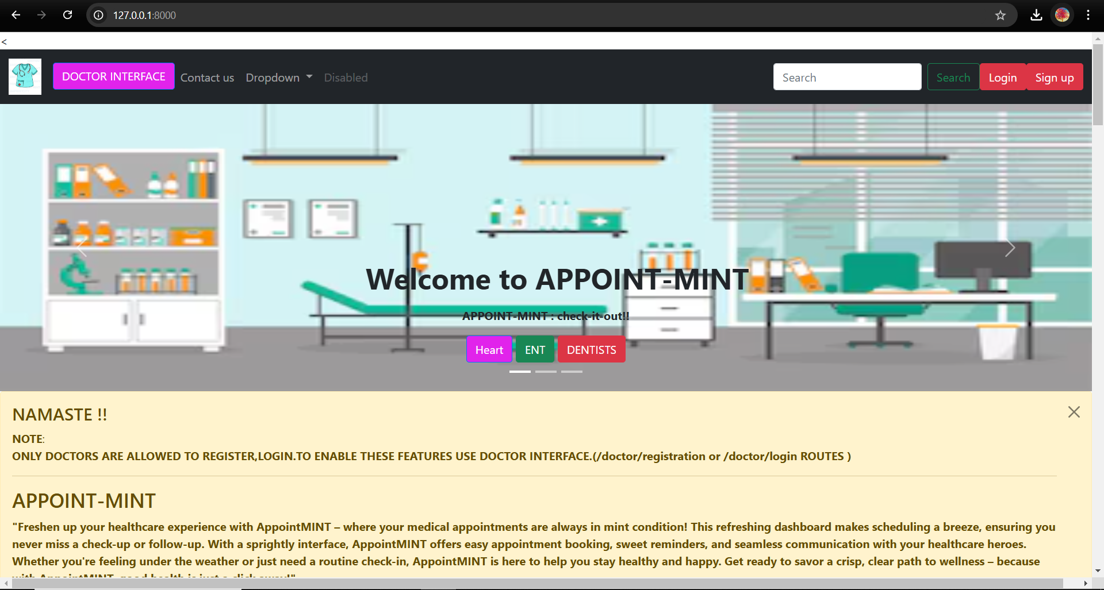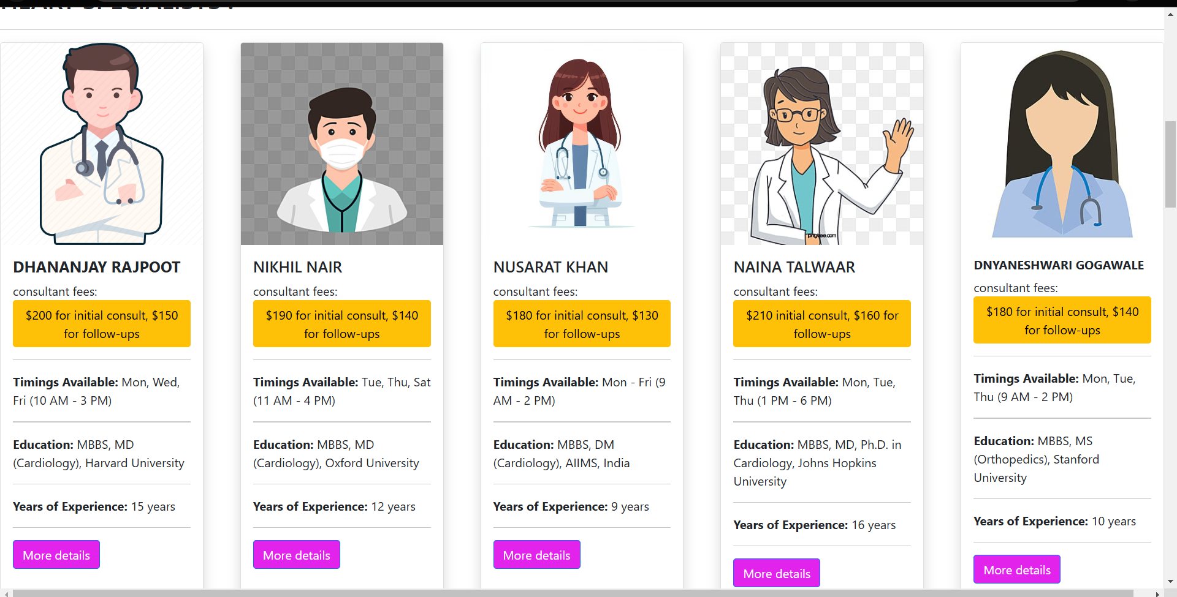

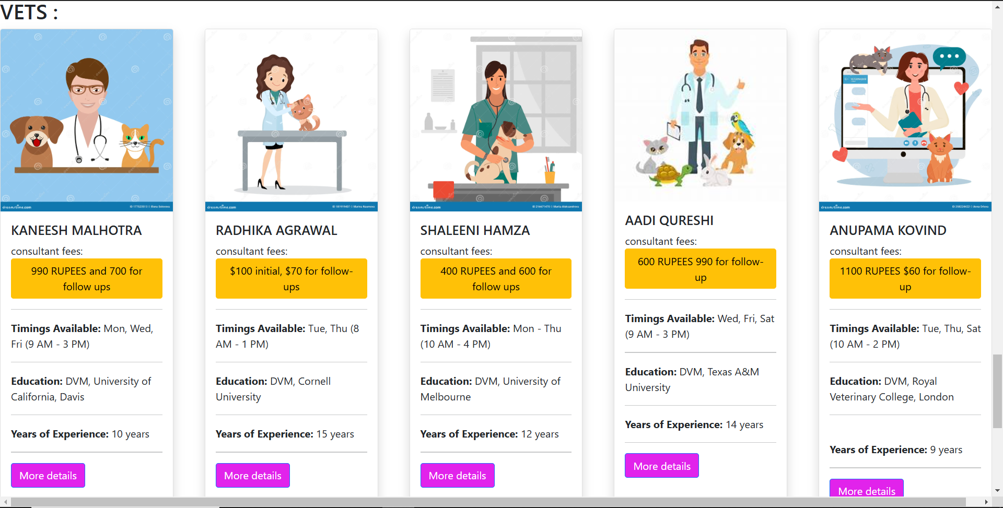 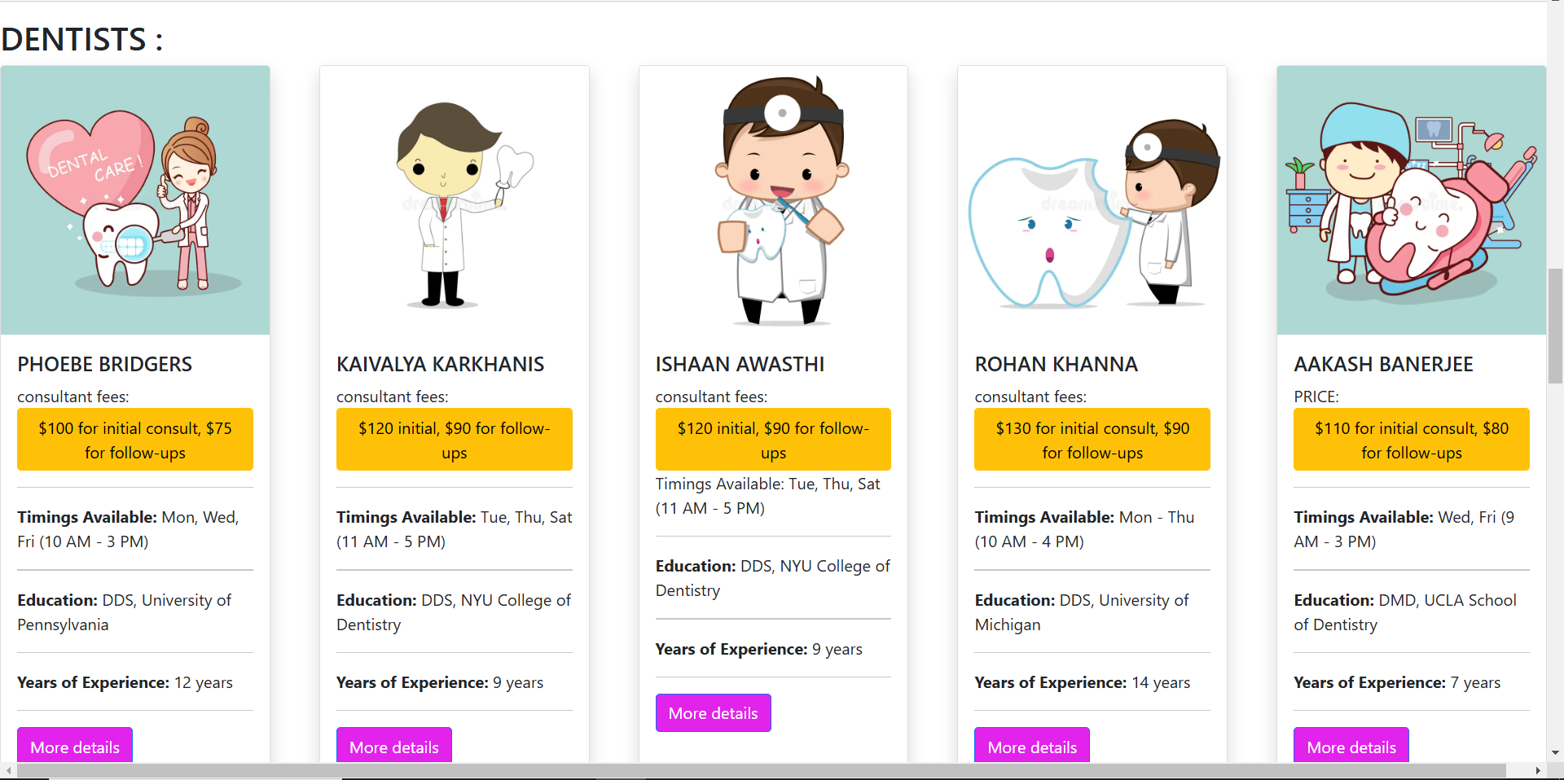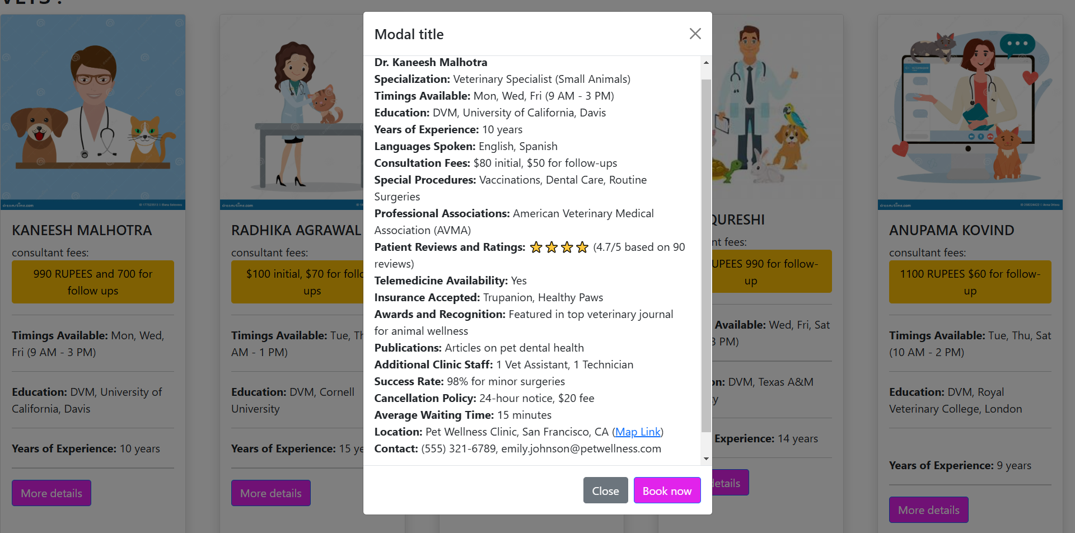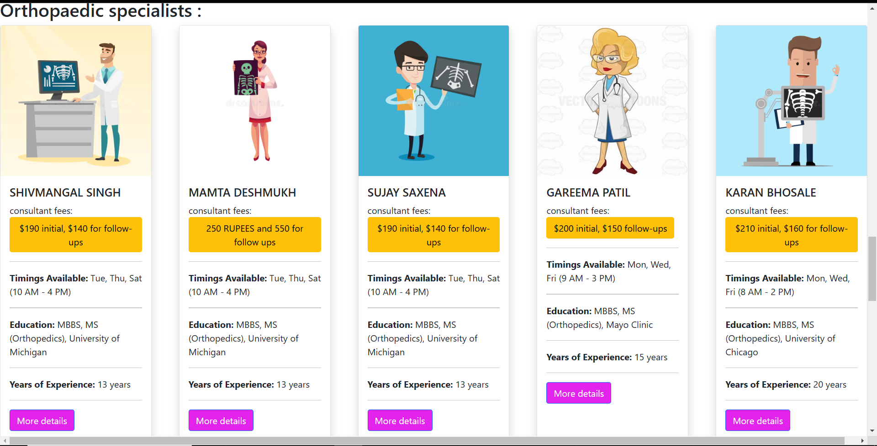

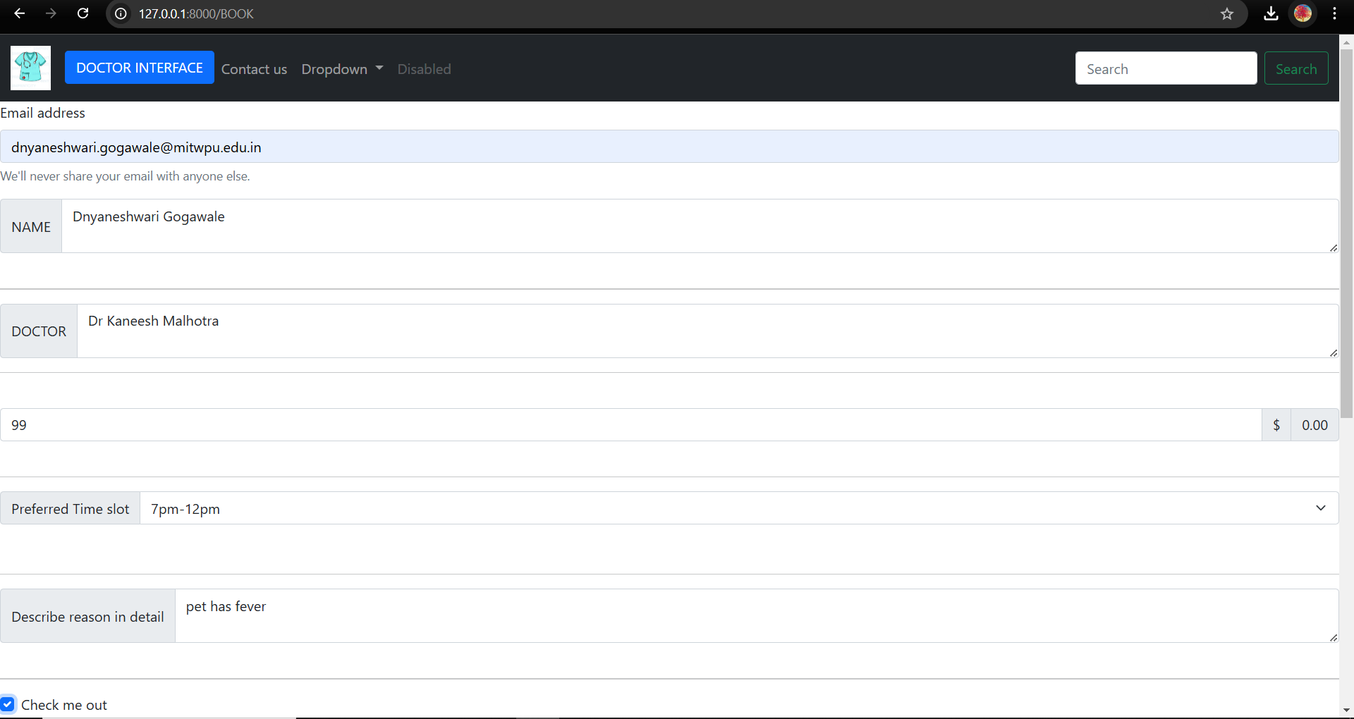

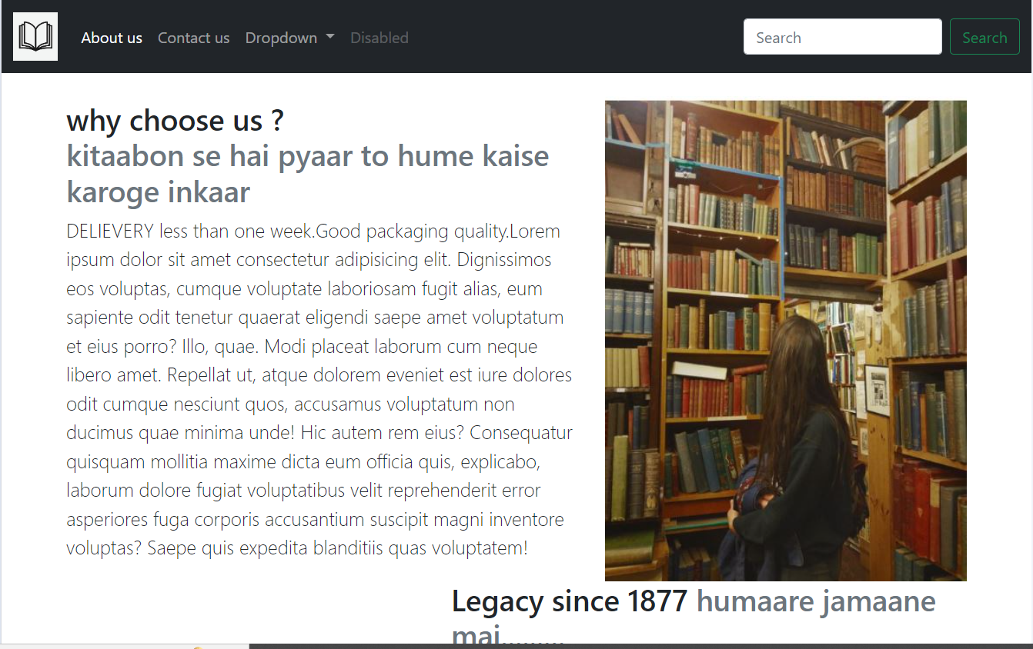

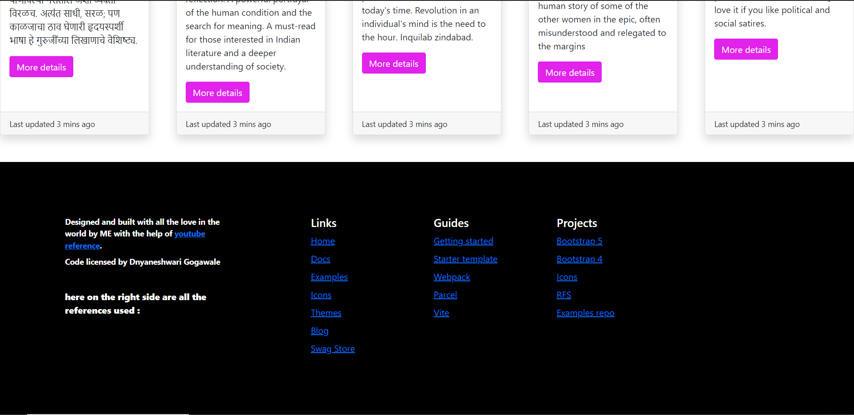

**DOCTOR-INTERFACE :**

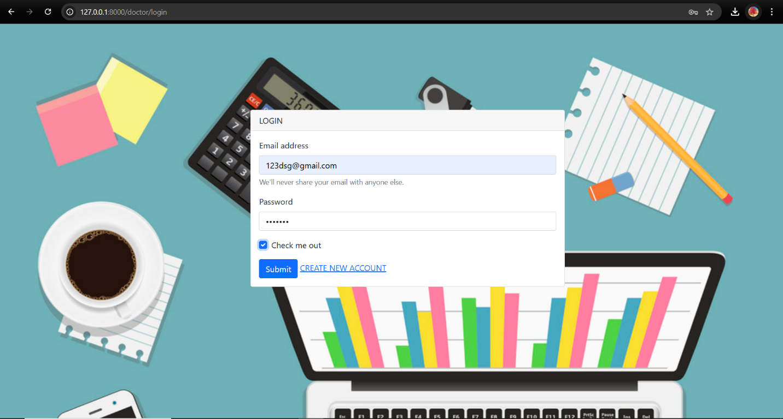

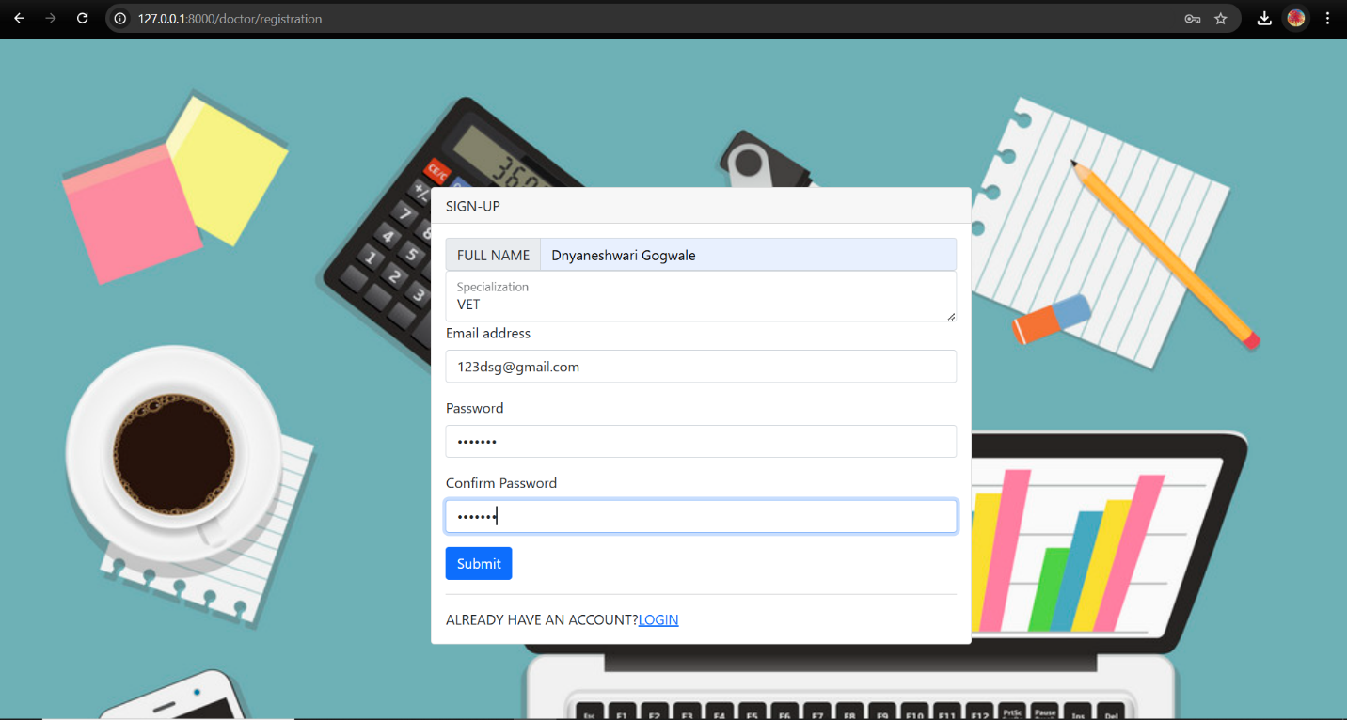

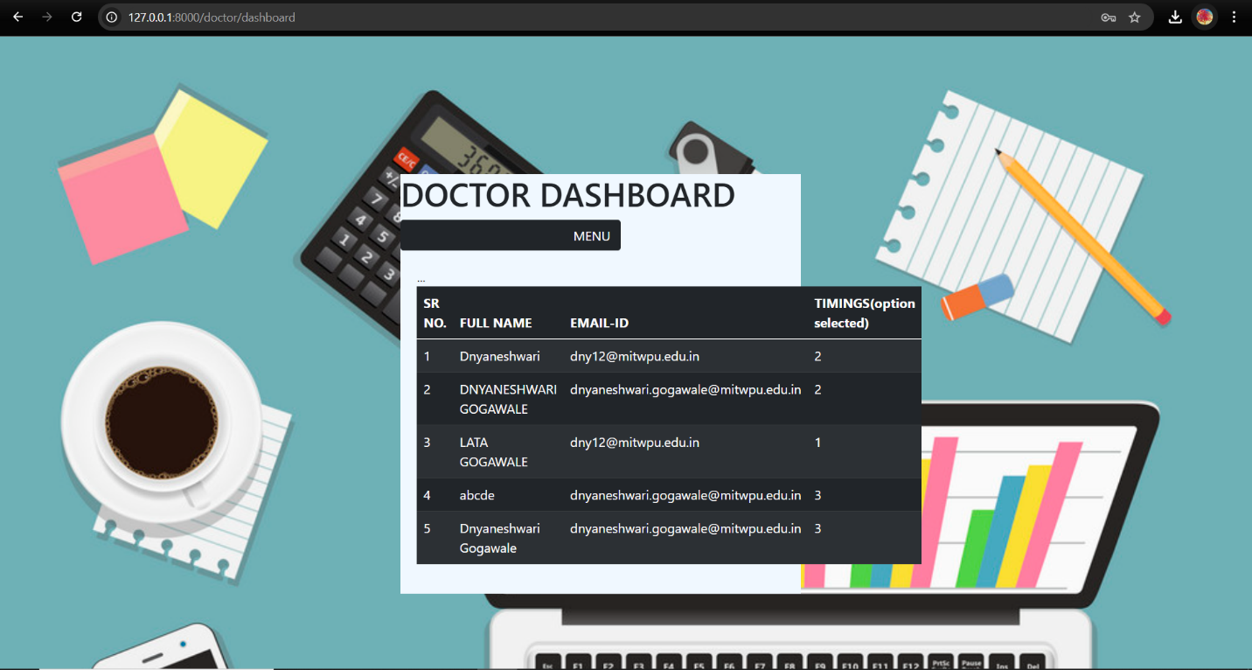

**Data collected in LARAVEL FRAMEWORK:**

**LARAVEL DATABASE :TABLE :APPOINTMENTS:**

This table has all the information on clients’ appointment.this is also used in DOCTOR dashboard to retrieve this information and show it to the doctor about his appointments . (as can be seen from the image of table a doctor dashboard )

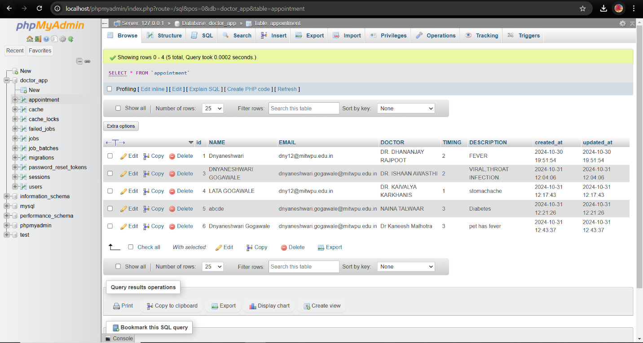

**LARAVEL DATABASE :TABLE :USERS :**

This database collects all information about the details of the doctor user of registration and logging in .

This database is used when a registered user wishes to log in.This data base is helpful in cross checking the info related to the user .

HASHING done to keep passwords safer .

